HEALTH SECTOR PERFORMANCE PROFILE REPORT 2010 UPDATE

Mainland Tanzania July 2009 – June 2010

Ministry of Health and Social Welfare

Acronyms

ANC Antenatal Clinic
ART Antiretroviral Therapy
CCHP Comprehensive Council Health Plan
CFS Consolidated Fund Services
CHF Community Health Fund
CHMT Council Health Management Team
DDH District Designated Hospital
DPP Department of Policy and Planning
EmOC Emergency Obstetric Care
FBO Faith Based Organization
HMIS Health Management Information System
HSF Health Services Fund
HSSP III Health Sector Strategic Plan III
HRIS Human Resource Information System
ILS Integrated Logistics System
iPTP Intermittent Presumptive Treatment (for pregnant mothers)
ITN Insect side Treated Net
JAHSR Joint Annual Health Sector Review
LGA Local Government Authority
MKUKUTA Mkakati wa Kukuza Uchumi na Kupunguza Umaskini Tanzania
MMAM Mpango wa Maendeleo wa Afya ya Msingi
MMR Maternal Mortality Ratio
MOFEA Ministry of Finance and Economic Affairs
MOHSW Ministry of Health and Social Welfare
MSD Medical Stores Department
MTEF Medium Term Expenditure Framework
NACTE National Council of Technical Education
NHIF National Health Insurance Fund
NBS National Bureau of Statistics
OPD Outpatient Department
P4P Pay for Performance
PER Public Expenditure Review
PMO-RALG Prime Minister’s Office-Regional Administration and Local Government
PMTCT Prevention of Mother to Child Transmission
POPSM President’s Office, Public Service Management
PPP Public Private Partnership
RCH Reproductive and Child Health
RDT Rapid Diagnostic Test (for malaria)
RHMT Regional Health Management Team
SWAp Sector Wide Approach
TB Tuberculosis
TDHS Tanzania Demographic and Health Survey
THMIS Tanzania HIV/AIDS and Malaria Indicator Survey
TIKA Tiba kwa Kadi

Table of Contents
Acronyms 1
Table of Contents 2
Foreword 4
Chapter 1: Introduction 6
Table 1: Proposed Formats for Health Sector Performance Profile Report 6
Chapter 2: Health Sector Performance Indicators 8
2.1 Progress towards Health Status of the Population 8
Neonatal, Infant and Under Five Mortality Rate 8
Figure1: Neonatal, Infant and Under Five Mortality Rate 8
Nutritional Status 9
Maternal Mortality Ratio 10
Figure 2: Maternal Mortality Ratio, by Region, 2009 10
Life expectancy at birth 10
Figure 3: Life expectance at birth from Rufiji DSS 11
Total Fertility Rate 11
2.2: Progress towards Service Delivery 11
Outpatient attendance per capita 11
Figure 4: OPD attendance per capita 12
Measles Vaccination 12
Figure 5: Measles vaccination in percentage by region 2009 12
DPT3 Vaccination 13
Figure 6: Proportion of children under one vaccinated 3 times against DPT –Hb3 13
Tetanus Toxoid Vaccination 13
Figure 7: Tetanus Toxoid Vaccination by region in 2009 14
Proportion of pregnant women starting ANC before 16 weeks of gestation age 14
Figure 8: Pregnant women starting ANC before 16 weeks of gestation age 14
Proportion of pregnant women attending ANC at least 4 times during pregnancy 15
Proportion of births attended in health facility 15
Figure 9: Births attended in health facility by region in 2009 15
Proportion of births attended by skilled health personnel 15
Maternal Case Fatality Rate in Health Facilities 16
Figure 10: Causes of Maternal Deaths in Health Facilities, 2009 16
Percentage of HIV positive women receiving ARVs 16
Figure 11: Percentage of HIV positive women receiving ARVs in 2009 17
Number of persons with HIV infection receiving ARV combination therapy 17
Figure 12: Proportion of patients on treatment and care receivingRVS 17
Malaria 18
Table 3: Performance of Malaria related Indicators 18
Tuberculosis and Leprosy 19
Tuberculosis Notification rate per 100,000 population 19
Figure 13: Percent of TB treatment success rate by region 2008 19
Proportion of leprosy cases diagnosed and successfully completed treatment 19
Incidence of cholera cases per 100,000 people 20
2.3 Progress towards Health System 20
Financial Resources 20
Source PER report 2009/10 20
Proportional of the national budget spent on health 21
Total Government and Donor on Budget Allocation to health capita 21
Indicator No 38: Proportion of population enrolled in CHF/TIKA 21
Human Resource for Health 21
Number of Training Institutions with full NACTE Accreditation 22
Chapter 3: Progress towards Milestones 2008/09 23
Chapter 4: MTEF Implementation Status 28
Table 7: MTEF implementation status in 2008/09 and 2009/10 28
Chapter 6: Highlights of the PER Update 29
Chapter 7: Human Resource Status in the Health Sector 30
Areas of good performance 31
Health Status 31
Service Delivery Development 31
Annexes 33
Annex 1: HSSP III Indicators up to 2009 33
Annex II: Performance of Health Status Indicators 41
Annex III: OPD Attendance per capital by region in 2009 42
Annex IV: Proportional of Children Under One Vaccinated Against Measles 2009 43
Annex V: Vaccine againist Diphtheria, Pertussis, Tetanus 44
and Hep B DPT_HB3 Coverage by age 12 Months in 2009. 44
Annex VI: Proportion of women receiving at least 2nd dose of TT vaccination 45
Annex VII : Proportion of pregnant women start ANC 46
before 16 weeks of gestation age 2009 46
Annex VIII : Deliveries in Health Facilities 2009 47
Annex IX: Maternal Deaths by Region and Causes 48
Annex X : Percentage of HIV positive women receiving ARVs to prevent MTCT 2009 49
Annex XI: Number of persons with HIV infection receiving ARV combination therapy 50
Annex XII: Percent of TB treatment success rate in 2009 51
Annex XIII: Treatment outcome of PB leprosy cases notified in 2007 52
Annex XIV: Treatment outcome of MB leprosy cases notified in 2006 53
Annex XV: Number of Reported, Admission, and Dealth Cases of Cholera by Region in 2009 54

Foreword
This Health Sector Performance Profile Report Update 2010 presents the assessment of health system performance in Mainland Tanzania for the financial year 2009/10. The Ministry of Health and Social Welfare (MoHSW), considers Monitoring and Evaluation as an important means for measuring effectiveness of the various inputs, processes, outcomes and their impact on the health system. In this way progress towards the National Health Policy objectives and international commitments can be measured with a high degree of certainty. The monitoring and evaluation process also identifies areas where performance has been lower than the expected target; requiring remedial measures to be taken on a continual basis.

This year’s report updates all indicator areas included in last year’s Performance Assessment report; which included the Health Sector Strategic Plan III Indicator Matrix. The major components of the assessment are:
- Performance in the 46 health sector performance indicators (including MDGs, MKUKUTA and PAF indicators),
- Assessment of progress towards achieving the Milestones outlined at the October 2009 Joint Annual Health Sector Review meeting,
- Implementation status of the Medium Term Expenditure Framework (MTEF),
- Assessment of health service performance at the Council level Highlight of key findings of the Public Expenditure Review for the Health Sector
- Assessment of the current status of Human Resources for the sector; and
- Conclusions (including outstanding issues and challenges)

Every effort has been made in this report to assemble available information, check it, and report accurately on the various indicators. Multiple sources of information have been used. The milestone assessment is a narrative report on actions taken and achievements registered. The MTEF report draws upon the implementation status of all activities in the 2009/10 financial year MOHSW plan and budget (grouped according to vote number.

The health financing section draws from the latest health sector Public Expenditure Review while the section on Council Health Sector performance draws upon the analysis of 21 Regional reports covering the implementation progress of the 132 Comprehensive Council Health Plans (CCHPs). The chapter on Human Resources, based on information collected by M & E staff from 132 councils, referral, specialized hospitals, training institutions and staff working with the MoHSW headquarters.

Reporting on the 46 health sector performance indicators has utilized data from a number of sources including HMIS, PER, TDHS 2009/10 and reports from various health programs (e.g. TB and Leprosy, NACP, NMCP, EPI, Reproductive and Child Health etc.

While this report significantly contributes to the MOHSW efforts towards effective and sustainable M&E, the scope of the analysis has been limited by some constraints, notably problems with the availability of robust and credible routine data. This chronic weakness highlights the critical importance of strengthening Health Information Systems particularly HMIS through M & E Section.

The work devoted to the construction and publication of this report was conducted under the coordination of the Directorate of Policy and Planning through the Monitoring and Evaluation Section and Working Group in collaboration with Joint Annual Health Sector Review Organizing Committee. Many thanks are extended to all who participated in one way or another in this endeavor particularly MoHSW staff and M & E Working Group.

Blandina S. J. Nyoni
Permanent Secretary,
Ministry of Health and Social Welfare, Mainland Tanzania

Chapter 1: Introduction

This report provides an overview of health sector progress and performance during financial year 2009-2010. It follows the Ministry of Health and Social Welfare’s (MOHSW) format for health sector performance profile which closely mirrors the Ministry of Finance and Economic Affair’s (MOFEA) format for annual performance reports (as summarized in Table 1 below). The main departure from the MOFEA’s format is an attempt to capture information on Council’s performance.

Table 1: Proposed Formats for Health Sector Performance Profile Report
Ministry of Finance and Economic Affairs Format | Health Sector Performance Profile Update
Part 1: Foreword, Introduction | Chapter 1: Introduction & overview
Part 2: Health Sector Performance Indicators | Chapter 2: Progress against 43 health sector indicators
Section 2.1 Progress towards Health Systems | Progress towards Health Status  Progress in improving Service Delivery
Section 2.2 Progress in improving Service Delivery
Section 2.3 Progress in Health Status | Progress in Health Systems
Section 2.4 Milestones/Priority Interventions | Chapter 3: Milestones Report
Section 2.5 Issues, challenges | See concluding chapter
Part 3: Achievement of Annual Targets | Chapter 4: MTEF Implementation Status
n/a | Chapter 5: Review of Council Health Performance
Part 4: Expenditure | Chapter 6: Highlights from the Public Expenditure Review Update
Part 5: Human Resources Review | Chapter 7: Human Resource Status in the Health Sector
…Section 2.5 above | Chapter 8: Conclusion, Issues & Challenges

This report is intended to provide an objective, evidence-based assessment of performance with reference to official indicators and targets as set in the Health Sector Strategic Plan III (HSSPIII). The data reported here come from a variety of official sources, including:
- Service delivery statistics from Ministry of Health and Social Welfare (MOHSW)
- Expenditure data from the Public Expenditure Review (PER) update
- MOHSW annual implementation report (Physical and Financial) for 1st July 2009 to 30th June 2010
- Milestone implementation status report from MOHSW
- Human resource data collected by the MOHSW through DMOs offices
- Tanzania Demographic and Health Survey (2009/10) preliminary report
- Draft report on Comprehensive Council Health Plans 2009/10
- UNICEF’s situation analysis report in health, water and sanitation for Tanzania Mainland 2009

Chapter 2 presents the latest performance information on 46 HSSPIII health sector indicators. These comprise a mix of input, output, outcome and impact indicators.

Chapter 3 provides a summary of progress against the Milestones that were agreed at last year’s Joint Annual Health Sector Review (September 2009).

Chapter 4 examines implementation performance against the strategies, objectives and targets set out in the Medium Term Expenditure Framework (MTEF) of the MOHSW for financial year 2009/10.

Chapter 5 reviews Council’s health performance, drawing upon the Regional/Central review of Council Comprehensive Health Plans (CCHPs) and their implementation.

Chapter 6 provides highlights on health sector expenditure, based on the 2009 Public Expenditure Review (PER) update.

Chapter 7 summarizes information on Human Resources for Health.

Chapter 8 provides conclusion, issues and challenges.

Chapter 2: Health Sector Performance Indicators

This section present the latest available information against the health sector performance indicators as presented in HSSP III. This is a new set of indicators evaluating the new Health Sector Strategic Plan III (see Annex 1 for the list of HSSP III indicators with baseline and target figures). HSSP III has 46 performance indicators clustered under the following thematic areas: health status of the population; service delivery; and health systems.

2.1 Progress towards Health Status of the Population

There are 12 indicators which are meant to measure the performance of the health status of several population groups. The indicators of interest are: on mortality rates (neonatal, infant, and maternal mortality), HIV prevalence, life expectancy, Total Fertility Rate (TFR) and child nutrition performance.

Index II summarizes the 12 indicators used to measure the health status of the population. It is worth noting that most of the data needed to measure these indicators are collected periodically, thus some have been updated using preliminary results from TDHS 2010, while other indicators will be measured with other type of surveys to be conducted in the near future. For missing data, proxy indicators have been supplemented by HMIS which is largely health facility data.

Neonatal, Infant and Under Five Mortality Rate
Neonatal mortality measures the probability of dying in the first month of life, while Infant mortality is the probability of dying before the first birthday and Under-five mortality provide probability of dying before the fifth birthday. These indicators reflect a country’s level of socio-economic development and quality of life. Analyzing these three indicators it can potentially predict the overall performance of the health sector. The rise or decline of these indicators is attributed to various social economic factors. Preliminary results from TDHS 2009/10 shows significant decline of child mortality specifically infant and Under Five Mortality Rate (Figure 1). However, high neonatal deaths remain a significant challenge, accounting for 32% of all under five deaths in Tanzania.

Figure1: Neonatal, Infant and Under Five Mortality Rate
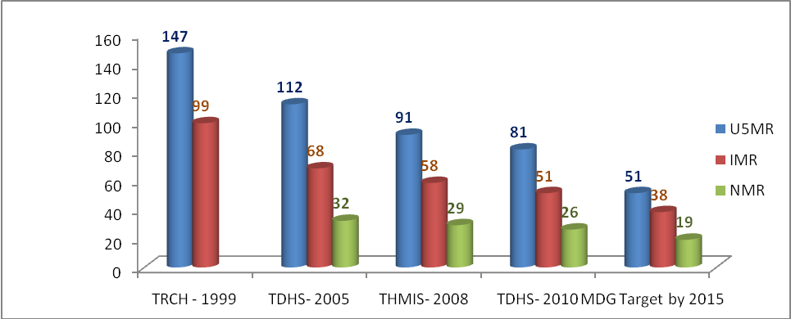

Nutritional Status
The nutritional status of young children is a comprehensive index that reflects the level and pace of household, community, and national development. Malnutrition is a direct result of insufficient food intake or repeated infectious diseases or a combination of both. It can result in increased risk of illness and death and can also result in a lower level of cognitive development. There are three standard indices of physical growth that describe the nutritional status of children. First, children who are stunted are considered too short for their age, Height for age (stunting), which is a measure of linear growth, and deficiency indicates a long-term and cumulative inadequacies of nutrition and is frequently associated with poor overall economic conditions. The second indicator of a child experiencing health and /or nutrition deficiency is wasting. Wasting is defined clinically defined as a child who is too thin for their height. Child’s weight in relation to their height (wasting), is used to measure body mass in relation to body length; and, describes current nutritional status and this may be the result of inadequate food intake or recent episodes of illness causing loss of weight. And third, Weight for age (underweight) which is primary, a composite index of both weight for height and height for age, and is difficult to interpret it and in this report the first two indices have been used. Survey findings have revealed that children below five years of age are most vulnerable in terms of health, nutrition and social development.

In 2005 survey 38 percent of children under 5 were moderately stunted, while 13% were severely stunted (Table1). Preliminary results from 2009/10 TDHS disclose 42.3 percent of children Under 5 were moderately stunted which is an increase of 4.4 percent. Also, from the same survey chronic malnutrition is 16.6 percent which is an increase of 3.6 percent. In 2005 survey three percent of children under five were wasted and less than one percent was severely wasted. Preliminary result from 2009/10 TDHS shows that 4.6 percent are wasted or thin, a condition reflecting acute malnutrition, while 1.1 percent are severely wasted. In both counts moderate and severe malnutrition as increased among under five children. This implies no improvement on nutritional status indicators as are far below from MKUKUTA target and 2015 HSPSIII target, which means more effort is needed to achieve both targets for stunting and wasting.

Table 2: Indicators on nutritional status
Indicator definition | Status 2004/05 | Status 2009/10
Proportion of under-fives moderately underweight (weight for age) | 38% | 42.3%
Proportion of under-fives severely underweight (weight for age) | 13% | 16.6%
Proportion of under-fives moderately stunted (height for age) | 3% | 4.6%
Proportion of under-fives severely stunted (height for age) | < 1% | 1.1%

Maternal Mortality Ratio
Maternal mortality ratio is measured periodically through Tanzania Demographic and Health Surveys (TDHS). The latest estimate from TDHS 2004/05, estimated Maternal Mortality Ratio (MMR) at 578 maternal deaths per 100,000 live births. Preliminary results from TDHS of 2009/10 shows MMR has declined to 454 deaths per 100,000 live births. This is a notable improvement but relatively the maternal deaths are still high requiring more effort to attain MDG goal which is 265 per 1000,000 live births. Also, the same goal is used for the MKUKUTA target. The new estimates concede with the general trend observed from facility data which provide proxy estimates. It is categorized as a proxy indicator because it is only portion of all deaths which occurs at health facilities. Hence, the value reported is understated compared with community based information. Trend analysis of facility data can provide a measurement of the increase or decrease of the MMR in the community. Figure 2 shows regional variations such that some reported the MMR below 100. Overall, measuring performance using health facility data shows a substantial decline of MMR from 162 in 2008 to 96 in 2009.

Figure 2: Maternal Mortality Ratio, by Region, 2009
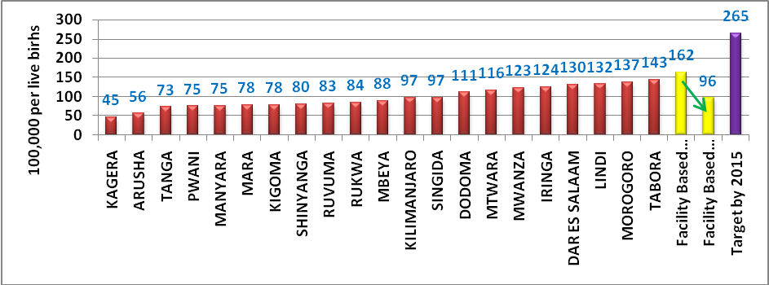

Life expectancy at birth
Life expectancy is the estimate of the average number of additional life years a person could expect to live if the age-specific death rates for a given year prevailed for the rest of his/her life. It is a hypothetical measure because it is based on current death rates and actual death rates change over the course of a person’s lifetime. Results from previous population censuses show that life expectancy rate has been increasing very slowly. In 1978, life expectancy in the United Republic of Tanzania (URT) was recorded at 44 years. It rose to 50 in 1988 and increased slightly to 51 in 2002. These estimated are well below the expected life expectancy of 56 and 58 years which was earlier projected. Although the prevalence of major diseases appears to be declining, the current HIV/AIDS prevalence rate may have been one of the major contributors to the slow increase of life expectancy in Tanzania. However, with substantial decline in child mortality, it is projected that on average, people in Tanzania have improved their life expectancies significantly. A good example of the measured change in child mortality is demonstrated by the Rufiji Demographic Surveillance Site (DSS) in Coast region. As a result of effective to health interventions delivered between1999 and 2007, child mortality declined remarkably. In fact, the reduction in child mortality increased life expectancy by 5-10 years during the surveillance period (figure3). Using NBS projections, it is now estimated that life expectancy in 2010 is around 57 for males and 59 for females. This will be confirmed by the 2012 population census results.

Figure 3: Life expectance at birth from Rufiji DSS
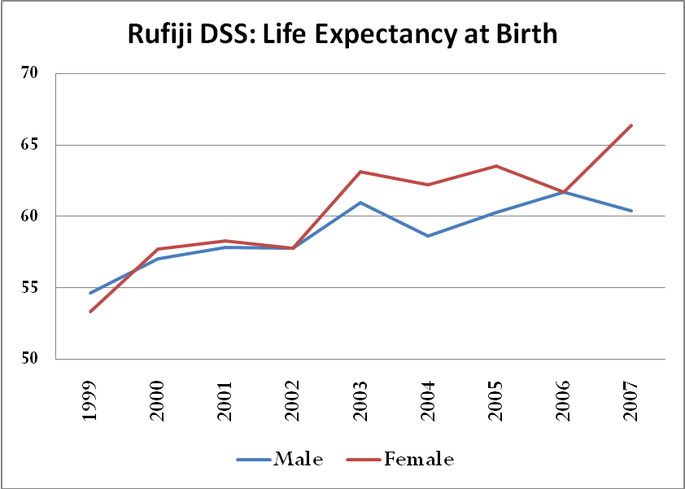

Total Fertility Rate
Total Fertility Rate (TFR) analysis is based on the birth histories collected from women age 15 -49 interviewed during surveys or censuses. Information from the birth history is used to assess current and completed fertility. To obtain such information women are asked a series of questions to determine a number of live births that had occurred in their life time. Then, for each life birth, information is collected on the name, age, sex and survival status of the child. For dead children, age at death is recorded. From TDHS 2009/10 preliminary result shows a slight decline of TFR to 5.4 from 5.7 in 2004/05 (TDHS).

2.2: Progress towards Service Delivery
Service delivery indicators include outpatient attendance, vaccination coverage, access to reproductive health services, and indicators measuring HIV and AIDS, malaria, tuberculosis and leprosy, infectious and non-communicable disease performances.

Outpatient attendance per capita
One of the key indicators to assess performance on the provision of health services in Mainland Tanzania is to understand the number of people attending and receiving services at health facilities during periods of illness. A good indicator of this is the outpatient attendance per capita. This indicator shows the extent of facility utilization by the population. If Out Patient Department (OPD) attendance is found to be high in the public health facilities, it implies that the population is highly satisfied by provision of services in these facilities. Below, Figure 4 displays the OPD attendances per capita in Mainland Tanzania regions. It is calculated using the denominator of population projections up to 2009. The OPD attendance per capita is high in the Mara (1.45) and Pwani (1.35) regions. The lowest OPD per capita is observed in three regions namely Kagera (0.23), Mbeya (0.44), Manyara (0.46) and Rukwa (0.47). The Tanzania Mainland OPD attendance per capita is 0.74; which increased from 0.68 of the previous year. However, this remains below the 2015 HSPS III target of 0.80.

Figure 4: OPD attendance per capita
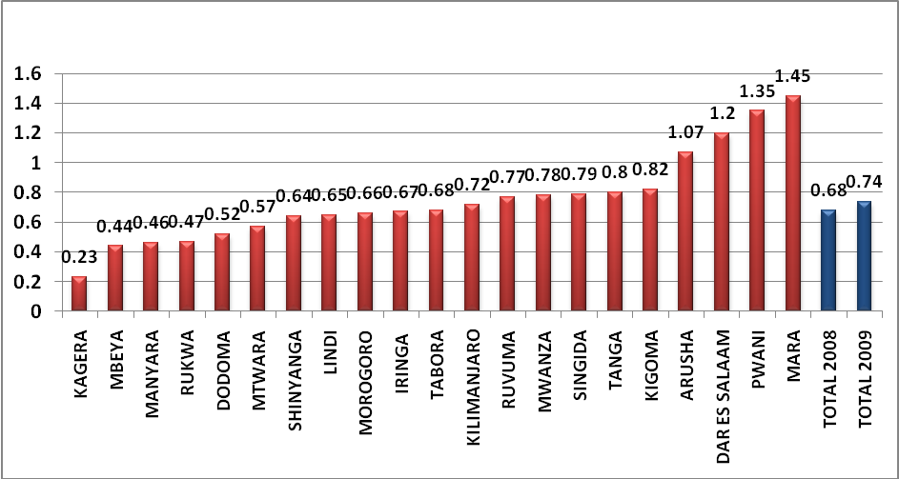

Measles Vaccination
This indicator measures the percentage of the total number of children below one year of age vaccinated against measles in a given population. It enables monitoring of immunization of children against the preventable diseases. Immunization is considered to have a high impact on child mortality reduction. The numerator for this estimation is calculated using the total number of children under one year vaccinated against measles in the numerator while the denominator is comprised of the total number of Children Under one year in a specified year. The indicator value in 2009 is 91% which has increased from 88% in 2008 (figure 5). This figure is well above the HSSPII 2015 target of 85%. For future years, the current rate should be maintained or improved further as there is room for additional improvement. Despite the general trend demonstrative overall good performances, a few regions need to improve their performances. These are: Rukwa (53%), Manyara (70%) and Lindi (78%).

Figure 5: Measles vaccination in percentage by region 2009
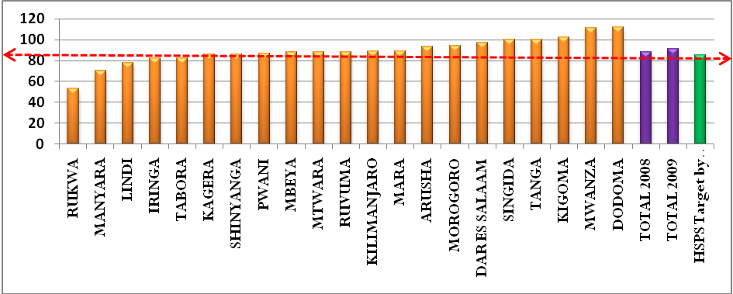

DPT3 Vaccination
Measurement for DPT_HB3 is defined as the proportion of children under one year vaccinated 3 times against three antigens. By 2004, the DPT-HB3 coverage peaked at 94%. Unfortunately, this was followed by a sharp decline to 83% in 2007. However, 2008 saw an increase by 3 percentage points or 86%. Performance in 2009 was 85.7%. This remains slightly below the previous year’s performance yet above the HSPSIII 2015 target of 85%. Conversely, more improvement can be achieved if a primary program focus provided to regions with low coverage such as Rukwa (65.7), Kigoma (67.5), Lindi (70.8) and Tabora (73.5).

Figure 6: Proportion of children under one vaccinated 3 times against DPT –Hb3
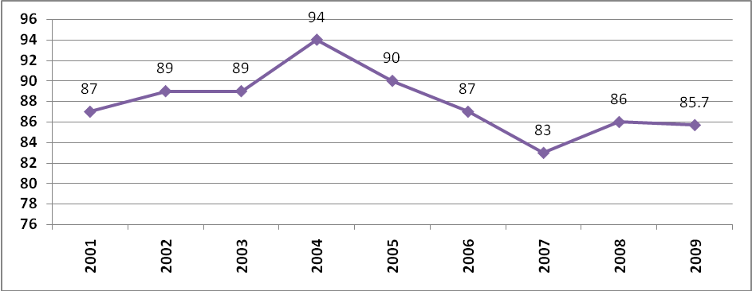

Tetanus Toxoid Vaccination
Tetanus toxoid injections (TT+) are given during pregnancy to prevent neonatal tetanus, an important cause of infant deaths. The injections are an important part of antenatal care. Because of this, the MoHSW advocates for all women of reproductive age are vaccinated before they become pregnant. Tetanus is still a relatively common cause of death among newborns in Tanzania; indicating a need for more efforts devoted to increasing vaccination coverage and safer delivery practices. The current status of vaccination performance is provided in Figure 7. Generally, health facility reports reveal that the percentage of pregnant women receiving the TT+ vaccine has decreased from 85 percent in 2008 to about 73.1 percent in 2009. Regional trends show remarkable differences. For example, health facilities in Pwani, Dodoma, Tanga and Morogoro regions show the highest rates (above 85 percent) for pregnant women receiving TT+2. In comparison to the rest of Tanzania’s regions, the average TT+ vaccination was below 85%, with Mwanza and Kigoma regions below 50%.

Figure 7: Tetanus Toxoid Vaccination by region in 2009

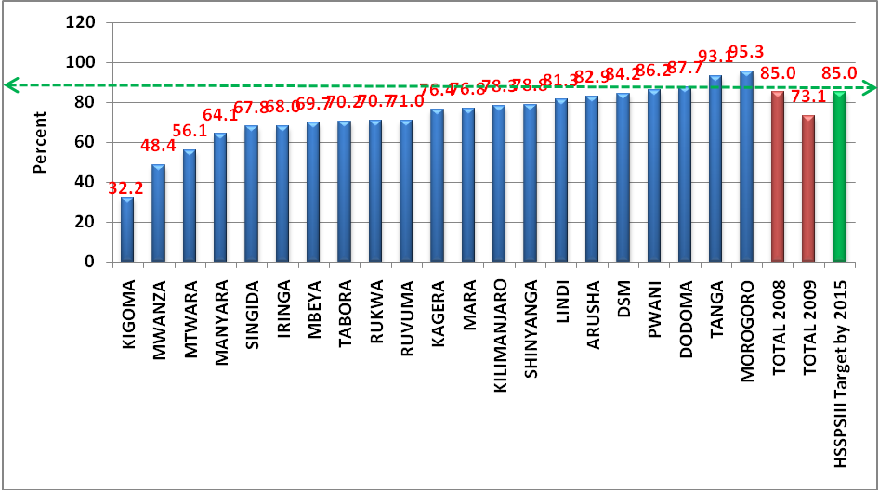
Proportion of pregnant women starting ANC before 16 weeks of gestation age
Figure 8: shows the proportion of women starting ANC before 16 weeks of gestation. In 2009, the national level was 47 % as compared to 14% from the previous baseline year (2008). Assessing regional differentials, Morogoro is leading (90%) with the highest proportion of women who attend ANC before 16 weeks of gestation while Arusha has the lowest (26%). The assessment of this analysis is done by assessing trend patterns. No target was set for this indicator in the HSSPIII. In spite of this, in using the Reproductive and Child Health (RCH) target, (60% by 2010), the current performance is significantly behind the RCH target; which implies that a more intervention is needed and required.

Figure 8: Pregnant women starting ANC before 16 weeks of gestation age
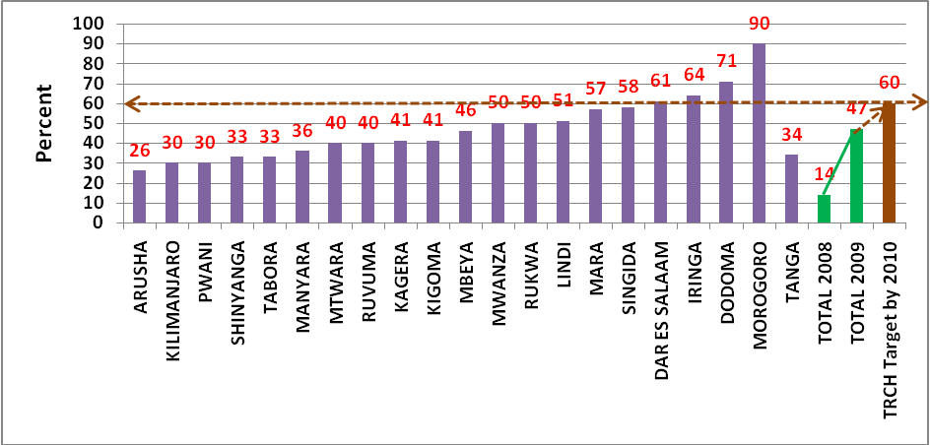

Proportion of pregnant women attending ANC at least 4 times during pregnancy
This indicator is defined as the number of pregnant women attending ANC at least 4 times during pregnancy as a proportion of the total number of pregnant women in a given population. The proportion of pregnant women attending ANC at least 4 times during pregnancy was 64% in 2004/05. However, 98% of pregnant women attended at least one ANC visit during this time (TDHS 2004/05). An update for this indicator will completed using the new data generated from the TDHS 2009/10 - which is currently in progress.

Proportion of births attended in health facility
This indicator measures the number of deliveries conducted in health facilities as the percent of the projected number of births. Basing on the 2009 HMIS/ Reproductive and Child Health (RCH) data, on average, 54% of deliveries were attended in health facilities (figure 9). The 2009 data implies that health facility deliveries increased from 51% and 52% in 2007 and 2008, respectively. The 2005 TDHS results revealed that 37.5% of expected births took place in government facilities; 3.1% in non-profit facilities and 6.4% in private-for-profit facilities (making 47% overall). Assuming that the RCH data accurately captured only government and non-profit facilities, it indicates that the proportion of births in health facilities has improved from 41% (2000-2004) to 54% in 2008 - a 13 percentage point increase. Recent TDHS 2009/10 preliminary result shows the proportion of births attended by trained personnel in health facility is 50.6% and 50.2% delivered in a health facility. Comparatively, facility based results does not differ very much with survey based results. The general conclusion is that Compared with the 2015 HSPSIII target of 80%, this entail more effort is required to achieve 2015 HSSP III target.

Figure 9: Births attended in health facility by region in 2009
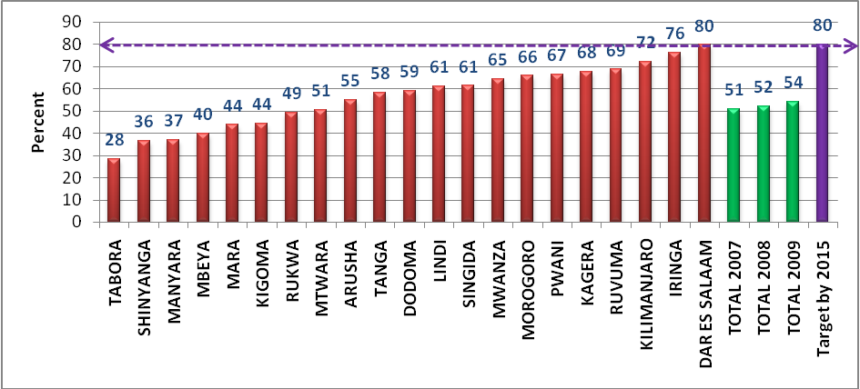

Proportion of births attended by skilled health personnel
This indicator measures the number of deliveries conducted by skilled health personnel as a proportion of projected number of births. The most recent estimate of 46% is from the 2004/05 TDHS. An update for this indicator will be done using the new data generated from the TDHS 2009/10.

Contraceptive prevalence rate
This indicator is measured as number of contraceptive active users (including and excluding condom) as a proportion of the total number of women of child bearing age. This was estimated to be 20% in 2004/05 TDHS. In 2008 data from facility indicated that 19 percent of women used contraceptives excluding condom. Preliminary result shows around 29 percent of family planning are currently using family planning method. This is an improvement compared with previous survey and it is about to reach the target of 2015 of HSSP III. Comparatively, the preferred modern method is implants (8.5%) followed by pills (5.1%)

Maternal Case Fatality Rate in Health Facilities
This indicator measures the number of deaths due to maternal complications as a proportion of the number of women admitted due to maternal complications. Until now, routine data collection captures the number of deaths due to maternal complications but does not report the number of women admitted due to maternal complications. In order to track the progress of this indicator, HMIS should start reporting this missing information. . Available information from HMIS is the number of deaths due to maternal complications and causes by Region reported in 2009 see Annex IX. Regions with the highest number of maternal deaths include Mwanza (176), Tabora (164), (153) and Dar es Salaam (137). This could be explained by the large number of facility deliveries and complicated referrals. Regions with the lowest numbers include Pwani (30), Arusha (32) and Lindi (39). Major causes of death at the health facility include Post Partum Hemorrhage (PPH) followed by eclampsia and anemia (Figure 10). In 2008 the same pattern was observed.
Figure 10: Causes of Maternal Deaths in Health Facilities, 2009
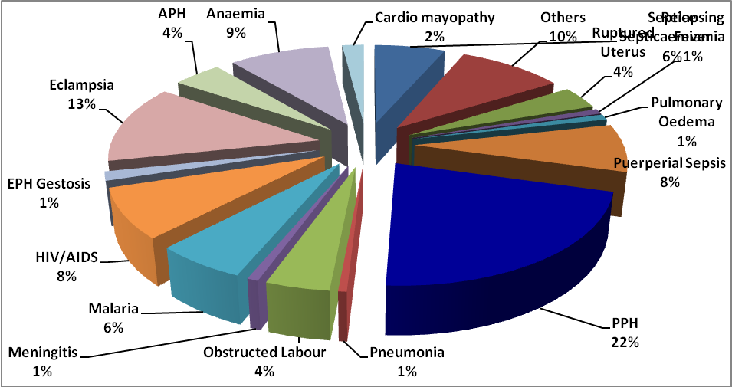

Percentage of HIV positive women receiving ARVs
This indicator measures the number of HIV positive women receiving ARV for Prevention of Mother to Child Transmission (PMTCT) as a proportion of the total number of HIV positive pregnant women per year. Figure 11 shows about 43% of HIV positive women were receiving ARVs to prevent MTCT in 2009; an increase from 34% in 2007 (RCH, 2009). This increase is significant and if the same pace is maintained, the 2015 HSPSIII target of 80% could be attained. Assessing regional variation, Dodoma, Mbeya and Tabora regions have almost achieved the HSPSIII target. However, dismal performances were recorded in Lindi (2.2%), Kilimanjaro (24.5), Pwani (32.8%) and Tanga (36.9).

Figure 11: Percentage of HIV positive women receiving ARVs in 2009
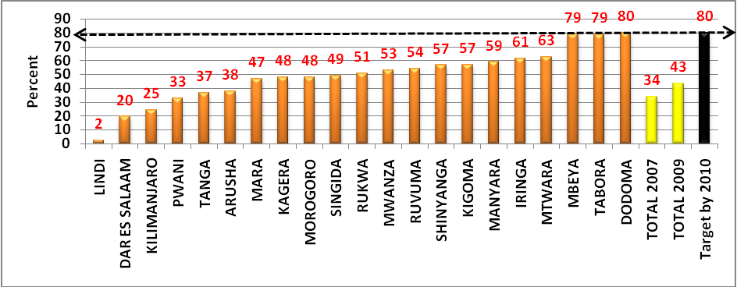

Number of persons with HIV infection receiving ARV combination therapy
By the end of May 2010, a 342,981 people were receiving ART; which is an increase from 248,280 in 2009 (Appendix XI). Despite a notable increase, this is below the National AIDS Control Program (NACP) target of 440,000 patients by 2010. This is equivalent to 80% of the target and it implies the likely hood of attaining NACP target by 2010. On average, 52% of persons with HIV infections receive care and treatments are receiving ARVS. Assessing the regional variations, the regions of Singida, Dodoma and Dar es Salaam have the highest proportion receiving ARVS while Tabora and Kigoma regions have lowest proportions receiving ARVS (figure 12)

Figure 12: Proportion of patients on treatment and care receiving RVS
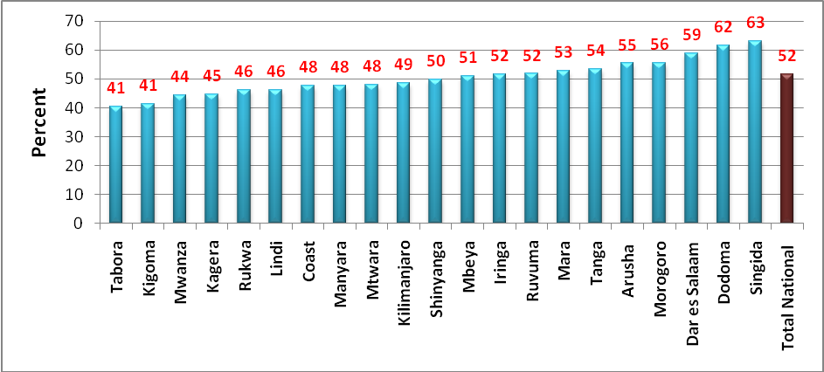

Malaria
Five independent malaria surveys were conducted between October 2007 and September 2008. These were the Tanzania HIV and Malaria Indicators Survey (Oct 2007-Feb 2008), National Institute for Medical Research Survey (Feb - May 2008), Population Service International Survey (Mar - May 2008), National Malaria Control Program Survey, and Tanzania National Bed net Strategy Survey (Jul-Sep 2008). Estimates from these surveys vary because of the methodology and timing of data collection. However, these estimates are still useful for NMCP M&E planning.

Official statistics for measuring the progress of malaria related indicators are obtained from the TDHS 2004/05, Tanzania HIV/AIDS and Malaria Indicators Survey (THMIS 2007/08) and preliminary results from TDHS 2009/10. Table 2 below shows the performance of the four malaria related indicators.

The first indicator is on the number of mothers receiving 2 doses of SP during pregnancy as a proportion of the total number of mothers attending ANC. This was estimated to be 22% in 2004/05 and it increased up to 57% in 2007/08 (THMIS). Surprisingly, preliminary results of TDHS (2009/10) show a sharp decline up to 27% compared with THMIS. The current estimate is far from achieving the 2010 HSSP III target of 60%.
Indicator on the proportion of vulnerable groups (pregnant women 15-49 years of age and children under 5) sleeping under an Insecticide Treated Net (ITN) the previous night. This was estimated to be 16% in 2004/05, 26% in 2007/08 and 64% in 2009/10 for children under 5 years of age. The recent estimate reveal sharp increase which means 2015 HSSP III target of 60% has already been attained. For pregnant mothers in 2004/05, 15% slept under ITN and in 2007/08 were 27%. New data from the TDHS (2009/10) 57% slept under ITN. This is a sharp increase implying that 2015 HSSP III target of 60% is about to be attained.
No new data are available to measure the performance of the prevalence of malaria parasitaemia in under 5 years. The most current estimate is 18% from the 2007/08 (THMIS).

Table 3: Performance of Malaria related Indicators
Indicator | Value (%) TDHS 2004/05 | Value (%) THMIS 2007/08 | Value (%) TDHS 2009/10
Proportion of mothers who received two doses of preventive intermittent treatment for malaria during last pregnancy | 22 | 57 | 27
Proportion of vulnerable groups (pregnant women 15-49 years of age) sleeping under an ITN previous night | 15 | 27 | 57
Proportion of vulnerable groups (children under 5) sleeping under an ITN previous night | 16 | 26 | 64
Proportion of laboratory confirmed malaria cases among all OPD visits (disaggregated under 5 and over 5) | - | - | -
Prevalence of malaria parasitaemia (under 5 years) | - | 18 | -

Tuberculosis and Leprosy
The Tanzania National Tuberculosis and Leprosy Program (TNLP) is one of the most successful TB programs in the world. TB notification rates, treatment success and the proportion of leprosy cases diagnosed and successfully completed treatment have improved for the period of 2008 - 2009.

Tuberculosis Notification rate per 100,000 population
This indicator is measured as the number of tuberculosis cases diagnosed as a proportion of the total population. This was estimated to be 163/100,000 in 2006 (TB&LP2006) and remained the same in 2008. No new data were obtained in 2009.

Percent of TB treatment success rate
The percent of TB treatment success rate, is defined as the number of patients who successfully completed treatment as a proportion of the total tuberculosis cases diagnosed. New data from the program shows high performance in the treatment success rate for consecutive years 2007 (87.7%) and 2008 (88%). These are an increase from 84.7% in 2006 (figure 13). The program has surpassed the global target of 85% and the 2015 HSSPSIII target of 82%. In addition, the majority of the regions have also surpassed the HSPSIII target. Now, the challenge is to maintain these high rates in future years.
Figure 13: Percent of TB treatment success rate by region 2008
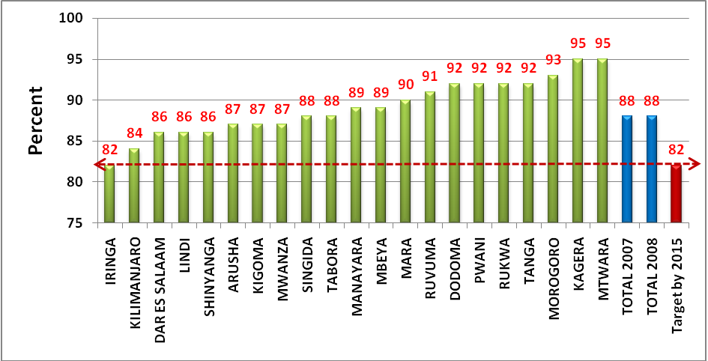

Proportion of leprosy cases diagnosed and successfully completed treatment
The proportional of leprosy cases diagnosed and successfully completing treatment is measured as the number of leprosy cases diagnosed and successfully treated as a proportion of the total number of notified leprosy cases. This was estimated to be PB 100%. According to computational methodology, the indicator, reflect two years back.

Incidence of cholera cases per 100,000 people
This indicator measures the number of cholera cases in a year as a proportion of the total population at risk. The incidence of cholera cases per 100,000 people was estimated to be 3,284 in 2005. At this time, there are no additional updates available. However, data reporting the number of cholera cases per region are available from the HMIS. As shown bellow, the majority of cholera cases were reported in Tanga (4,798 cases) followed by Mara (880 cases). There were no reported cases in the following seven regions: Iringa, Kagera, Lindi, Morogoro, Mtwara, Ruvuma and Tabora.

Proportion of treated cases of cholera who are deceased
This indicator measures the proportion of deceased patients who received cholera treatment. Out of the 2,391 cases identified in 2008, 73 of the treated cases died. Annex XV presents the number of treated cases that are now deceased. The figure shows that the majority of deaths were reported in the following regions: Kigoma, Lindi and Morogoro regions.

2.3 Progress towards Health System
Selected indicators to evaluate health systems include financial and human resources and performance of the logistics system. These are input indicators which represent how much the government is investing in Tanzania’s health sector in terms of financing health activities, human capital and facilitating delivering of requisite services.

Financial Resources
Indicators on financial performances provide an understanding the source of funds and to where are spent. The Government of Tanzania has explored a number of approaches in an attempt to bridge existing financial gaps. It has a mixed type financial structure supporting its health system. It largely comprised of a tax system of which 70% of the funding structure funding from public and foreign financial sources. These sources are complemented by a health insurance offering from the National Health Insurance Fund (NHIF), the Community Health Fund (CHF), and user fees in the form of cost sharing. The essence of having financial indicators is to permit close monitoring of funds to ensure they are channelled through the health sector from effectively and efficiently.

Table 4: Expenditure Performance Indicators for the Public Health Sector (TZS)
Particulars | 2006/07 | 2007/08 | 2008/09 | 2009/10
Nominal GDP (mil Tshs) | 17,941,268 | 20,948,403 | 24,781,679
Real GDP (mil Tshs) | 16,810,968.12 | 19,188,737.15 | 21,882,222.56
Government Expenditure (mil Tshs) | 4,972,492.00 | 5,998,100.00 | 7,271,130.00 | 9,513,685
Health Expenditure | 668,751 | 818,238 | 1,008,260 | 665,141
Health as % of nominal GDP | 3.73 | 3.91 | 4.07
Health as % of Real GDP | 3.98 | 4.26 | 4.61
Health as % of Gov't expenditure | 13.45 | 13.64 | 13.87
Per capita health expenditure | 17,474.55 | 20,741.14 | 24,791.25
Population (mil) | 38.27 | 39.45 | 40.67
Inflation (%) | 6.3 | 8.4 | 11.7

Source PER report 2009/10

Proportional of the national budget spent on health
Analysis on the proportion of the total government expenditure going to the health sector has increased from 13.45% in 2006/07 to 13.87% in 2008/09. The trend implies that the government has been allocation more financial resources to the health sector for many years now. Nevertheless, the proportional budget spent on health is still below Abuja target of 15% by 2015 but it is within reach.

Total Government and Donor on Budget Allocation to health capita
The per capital spending has been increasing over the review period increased from 17,474.55 to 24,791.25 in 2008/09 (Table 3); an indication of improving health services for Tanzanian citizens. However, the per capita health spending is still low compared with 2015 HSSP III and MKUKUTA target which is Tsh 52,800/=.

Proportion of population enrolled in CHF/TIKA
The establishment of Community Health Finance which aimed to involve community to participate in financing provision of health services through cost sharing is not doing well. The MOHSW has a long way to reach the target of enrolling 80% of Tanzanian population by 2015. This is because the currently, 6.6% of Tanzanian population is enrolled in CHF/TIKA. This is a slight increase from previous year which was 5.6%.

Human Resource for Health
Human resource is one of the key components of the health systems. Unfortunately the number of skilled workforce in the health sector is inadequate at all levels. Indicator to assess the workload is to look at the number of professionals per 10,000 populations or population ratio per one professional. The table below shows some improvements over years based on projections by including graduates from medical schools. This is likely because there have been some improvement in certain cadres as there have been a number of initiatives being carried out by the Ministry of Health, including raising the number of trainees in MOHSW run institutions and university graduates. Ratios for Pharmacist, Pharmacy Technician and Laboratory Technicians are still very high despite some improvement recorded from 2006/07. Also, more doctors and Assistant Medical doctors are needed since the current ratios per population are still high according to international standards. It should be noted that some professionals have been combined in determining ratios and professional per 10,000 populations since it is known that many of the functions of doctors are performed by assistant medical officers (AMOs), who have received a clinical training similar to that of general physicians. This is the same for Pharmacist and Pharmacy Technicians.

Table 5: Selected professionals per 10,000 population and ratios
Indicator definition | No of professionals per 10,000 population in 2006/07071000p. | Population Ratios per population Ratio | No of professionals per 10,000 population in 2009/1007 009/10 per 100oo 00 pop. | Population Ratios per population
Medical Officers per 10,000 population | 0.3 | 1: 33,300 | 0.49 | 1: 20,408
Assistant Medical Officers per 10,000 population | 0.4 | 1:25,000 | 0.44 | 1: 22, 727
Medical Officers and Assistant Medical Officers per 10,000 population | 0.7 | 1:14,300 | 0.93 | 1: 10,752
Nurse-Midwives per 10,000 population | 3.8 | 1:2,600 | 4 | 1: 2,500
Pharmacist per 10,000 population | 0.07 | 1: 143,000 | 0.1 | 1:100,00
Pharmacist and Pharmacy technician per 10,000 population | 0.12 | 1: 83,000 | 0.17 | 1: 59,000
Lab technician per 10,000 population | 0.2 | 1:50,000 | 0.24 | 1: 42,000

Number of Training Institutions with full NACTE Accreditation
Currently there are 134 Health Training Institutions out of these only 15 Public Health training Institutions or 11.2% have FULL ACCREDITATION. The rest institutes are in different stages of registration and Accreditation

Chapter 3: Progress towards Milestones 2008/09

Table 6: Tanzania Health Sector SWAp Milestones 2009/2010
Area | Milestone | Process Action Plan | Comments / Indicators | Update
District Health Services | 1. Review and revise the CCHP guideline including the assessment tools and National Essential Health Package in line with HSSP3, MKUKUTA and other agreed sector strategies | 1 Draft TOR for review of CCHP Guidelines  2 Request funding of activity  3 Set up TWG and Carry out the review by representatives from LGAs, RHMT, FBO, CSO, MoHSW, PMORALG, and DPs  4 Final revised CCHP Guidelines | Output: CCHP Guidelines by March 2010  Important assumption:  Funds for review available and disbursed in time. | The milestone is almost achieved. The CCHP guidelines have been revised. The revision includes the assessment tools and the National Essential Health Package. Priority areas for implementation in FY 2010/11 were identified and sent to Councils through circular from MOHSW to ensure that these areas were incorporated in the respective Council Plans 2010/2011. The assessment of CCHPs for FY 2010/11 demonstrated that the priority areas had indeed been included in the plans for FY 2010/11.  Subsequent steps:  - The revised guideline will be disseminated to the implementers (LGAs, RS/RHMTs and Zonal Training resource centres).  - RHMT reporting template for compilation of reviewed CCH plans and progress reports will be updated in the course 2010.  - A particular review of the National Essential Health Package guidelines is planned for 2010/11.
Hospital Reforms | 2. All Regional Hospitals are supported to develop annual plans and the plans are put to use by July 2010. | 1 Prepare TOR for the activity  2Request and disbursement of funds  3Facilitators meeting to prepare training materials and agree on facilitation modalities  4 Facilitators visiting Regional Hospitals to assist HMTs develop strategic and annual plans | Output: Regional Hospital annual plans  Verification: Hospital Reports to Regions  Important assumptions:  Funds are disbursed on time.  Facilitators and resource people available in time  Expected funding: HSPS IV (MTEF) | 1A: TOR for finalizing training materials, and conducting a TOT on HMT modules was prepared.  1B TOR for conducting support to Regional referral Hospital management teams through training was prepared.  2A: Funds for conducting the planning support activities were disbursed late.  2B Facilitators have met to prepare training material and modalities. The training materials on the development of Regional hospital annual plans have been finalized, including a standard planning format and draft planning guide. Training will be facilitated to HMTs to develop Hospital strategic plans and annual plans. So far, a total of 12 out of 21 regional referral hospitals have developed annual and/or strategic plans. Most hospitals have adapted the priority areas outlined by the NEHP that are relevant to the Hospital setting, including interventions related to HRD, Equipment and infrastructure,  The submitted plans reflect obvious challenges that regional referral hospitals face: Limitation of funding and hospital management skills.  Criteria for assessing plans will be developed.  Planning template to be finalized  4 Due to the late disbursement of funds, the actual facilitation of HMTs was not conducted. Facilitation of 4 Regional Hospitals will take place in October 2010. Facilitation of the remaining Regional Hospitals has been included in plans for FY 2010/11.
Health Financing | 3. Final draft Health Financing Strategy and action plan completed by June 2010. | 1 Engage consultant  2 Carry out consultancy and submit report  3 Dissemination of report  4 Consultation process finalized by June 2010  5 All of the above coordinated and managed through the Health Financing Committee | Output: Final draft strategy  Important assumption:  Funding of consultancy: World Bank  DPs will provide funding of the remaining activities. | Some steps in the PAP completed and the milestone is half way achieved. Consultants have been engaged and some preliminary studies have started. A Health Systems Assessment has been completed. Other complementary studies like PER and Costing are under way.  The Consultants’ Inception Report will be submitted on 22nd August 2010. This report will show the time line for each activity and when should the Strategy be ready.
HRH / Social Welfare | 4. Staff recruitment, posting and retention processes strengthened by July 2010 | 1 Established norms clarified  2 All Districts report on vacancy rate as per established norm.  3 Regions consolidate vacancy data from the Districts  4 Regional administration and LGAs identify and list health and social welfare workers needing re-categorization and promotion by December 2009 | Indicators will be established based on the staffing norms building on the work load and the MMAM (i.e. No. of health facilities and vacancy rate of different cadres of health workers, e.g. clinical officers in all District dispensaries, AMOs in Health Centers, MOs in District) | 1a) The task of setting up staffing levels is ongoing. Definition of health services delivery levels, roles and activities, cadres required, and criteria to determine the numbers to perform identified activities has been done for Dispensary, Health Centre and Referral Regional Hospitals  1b) Human Resource Information systems has been developed and installed in all Districts and 6 Referral Hospitals in 5 regions. The system is capable of showing various important indicators such as attrition, retention, skills etc. In the private sector the Human Resource Information (HRIS) has been installed in 5 CSSC Zones.  2&3) Assessment of Vacancy rates in Districts and Regions indicate that in 2009/10 the number of vacant posts were 10,058.  4a) All 734 employees earmarked and budgeted for promotion in Vote 52 have been promoted up to June 2010.  4b) Up to June 2010 a total of 4090 new employees out of 6247 employment permit have been posted to various employing authorities.  4c) Retention efforts taken:  - Support in payment of salaries for Private health facilities (DDH/CDH) as well as grants to Voluntary Agencies.  - Provision of contracts for retirees and bonding after training.  - Building of health workers houses.  - Pay for performance is being implemented  - Various local incentive initiatives are implemented by Councils.
PPP | 5. PPP policy guidelines for implementation of PPP strategy finalized by August, 2010. | 1 Prepare TOR for the activity  2 Request and disbursement of funds  3 PPP focal person to draft PPP policy guidelines  4 Stakeholders meetings to input on the draft document | Output: Draft PPP policy guidelines  Important assumption:  Funds are disbursed on time.  Funding: DPs | 1 PPP TOR was prepared and PPP office in MOHSW established.  2 Funds for the PPP activities were negotiated and secured from DP.  3. Rather than outsourcing development of draft PPP policy guidelines, assignment was undertaken by PPP office with support of PPP Technical Advisor in April-June 2010.  4 Draft PPP guidelines were discussed and elaborated on at a key stakeholders meeting in July. Revised draft PPP policy guidelines completed in August 2010.  Subsequent steps:  A: Additional refinement of draft PPP policy guidelines to align guidelines with National PPP policy regulations and corresponding PPP Act.  B: To promote implementation of the PPP policy guidelines at national, zonal and district level.
M&E/  HMIS | 6. Ensure that there are established and funded posts for M&E staff at District and Regional levels by September 2010 | 1.Develop Job Descriptions for the District and Regional M&E positions  2 Advocate and negotiate with POPSM | Output: M&E positions at District & Regional levels established and staffed  Indicator: M&E positions at District & Regional level staffed / total number of Districts and Regions  Assumption: M&E strategy is finalised on time. | POPSM has granted employment permit for M&E staff at Regional and District levels. DMOS and RMOS were informed by PMORALG about this permission when attending a meeting in Dodoma to discuss implementation of milestones from JAHSR 2009.  MoHSW has no legal mandate to develop job descriptions for M&E staff employed by District Councils (i.e. Local Government Authority). Hence, the new M&E staff employed in DMO offices follows job descriptions used by the LGAs for M&E staff. The challenge is that such cadre is not available in the market.  The MoHSW M&E Unit has not yet received information to assess the exact number of newly recruited M&E staff in Regions and Districts.
Service Delivery  MNCH | 7. Increase resources for MNCH used as entry point to strengthen service delivery | 1. Costing of One Plan (including Maternity Waiting Homes) and of FP commodities to input directly in budget guidelines and translates in MTEF.  2. LGAs asked to allocate funds for MNCH activities as a priority.  3. Use of the Health Window of the LGDG to improve the infrastructure and supplies related to maternal and child health (supply of delivery kits, resuscitation kits, other equipment and vital and essential medicines)  4. Ensure that delivery kits are purchased (using MTEF funds) and distributed.  5. Improving referral system and supervision | Regular reporting by the MCH Working Group to the TC SWAp.  Funding: MTEF, Basket financing and LGDG Health Window  Measures that can be undertaken: Rehabilitation/improvement of facilities, equipment with EMONC, supply of medicines and commodities, improvement of the referral system, supervision etc.) | 1a) Costing for MNCH intervention in process but not yet fully completed.  1b) Costing FP implementation programme finalized and launched end of March. Estimates for FP commodities used in MTEF planning process. However funds still inadequate. Able to get additional support from USAID and UNFPA for implants and Depo-Provera. KFW supporting FP through PSI  2. Districts guided to include MNCH equipment and supplies and other one plan activities during DMO’s meeting organized by TAMISEMI in January.  2. TWG members co-facilitated dissemination of policy guidelines to RHMTS and guided on key roadmap activities to be implemented.  2. TWG held working sessions to review CCHP guidelines and submitted inputs to DHS Coordinator.(An important step towards districts putting right MNCH interventions)  3. MTEF includes funds to start distribution of delivery packs in two regions for the year 2010/11. Also additional delivery kits to be procured with basket funding  - Cold chain assessed and EPI is being support by CIDA and UNICEF to procure cold rooms. MSD to support expanding cold chain at zonal /regional levels  4a).Tender has been awarded for delivery kits and MNCH equipment procured with support of World Bank AusAID support and Swiss Cooperation.  TWG has identified task force to map out were equipment should be distributed when it arrives  4 b) Procurement of child and neonatal services equipment through Global Fund round 7 in process (MSD), but equipment is yet to be delivered.  5.Tender for procurement of 400 Motorbike ambulances awarded to Rangers Limited of South Africa – Delivery expected in September Task force in place to prepare distribution  -Under the support of UN JP2 , JP 6 and WHO/EU 34 ambulances and MNCH equipment procured  -Global fund round 10 proposal submitted –is integrated including low cost ambulances and strengthening integrated HIV/MNCH services including FP  -23 vehicles procured to strengthen EPI logistics and RCH supervision at regional level
Service Delivery | 8. RHMT role and capacities for supportive supervision as well as monitoring of the councils strengthened. | 1. Line item for RHMT created at Reg. Secretariat  2. RHMT to receive allocation from block grant + timely transfer of basket grant (at the beginning of FY).  3. RHMT to develop annual plans on how they will support the districts to implement HSSP III.  4. RHMT to compile and analyse data from the CCHPs of their region, and use this information to guide their interventions. | Indicator:  Assessment of RHMT reports presented and discussed in the SWAp meeting  Funding: MTEF + Basket Funds  Ensure that the Zonal team is included in providing support to the RHMTs.  Staff to support Zonal Teams is already in place in the Secretariat. | - A Line item for RHMT has been created at the regional secretariat and RHMT eight core members are officially recognised in the RS Team. Financial procedures are under discussion with the MOFEA on possibilities of allowing RHMTs to open bank accounts.  - RHMTs received allocation from basket fund timely. Block grant was so far released only for Regional hospitals but not for RHMT (as RHMT was not a line item in the MTEF 2009/10). A few regions allocated limited funds to RHMT for supervision only.  - In collaboration with the TC-RRHM the MOHSW conducted different interventions to give capacity to Regional Health Management Teams to perform better: For this year, all twenty one RHMTs prepared their own Strategic Plans (SPs) utilizing the knowledge/skills acquired through the SP training conducted in the previous year. These SPs were reviewed and feedback was given to the regions. Annual Planning templates were reviewed and used in 2010/11 plan preparations. These plans include RHMT ten major functions one of them being supportive supervision to CHMTs. Operational activities of these plans indicate how RHMT will support districts/CHMTs to implement HSSP111.  - All RHMTs are now compiling and analysing data from CCHPs. RHMT reports were presented and discussed at the SWAP meeting held in June 2010.A new template on reporting format has been developed by TWG-D/R to maintain uniformity of reporting system from all regions  - In collaboration with TC RRHM MOHSW has introduced the new system of in cooperating the Zone Health Resource Centres staff in conducting Central Management Supportive Supervision to the regions starting August 2010
Governance and account-ability | 9. User participation is increased by strengthening further CHSB and HFGCs. | 1. Revised CHSB and HFGC guidelines are discussed in the “Region & Council Working Group”, to be presented, discussed and endorsed in the TC SWAp.  2. Identify the bottlenecks to the use of collected funds and implement remedial measures.  3. MoHSW, PMORALG & MOFEA to clarify how facilities can open and operate their own account.  4. HFGC is empowered approve and monitor the use of the funds that are generated at the facility.  5. Disseminate information on rights and responsibilities of service users and those of the Health Services Boards.  6. Remind DEDs to ask health facilities to post information publicly on income and expenditure for the facility | Information on health funds (MTEF, BF, CHF, NHIF, Cost sharing etc.) and how they are used is included in the CCHP plans and reports.  Compilation of this information provided at the SWAp and JAHSR meetings.  Health Accounts opened for HC & Dispensary level.  Funding: MTEF + Basket Fund + NHIF/CHF | 1The guideline for establishment of CHSB has been revised and will be shared by stakeholders and TWG for comments.  1B Facilitator’s guide for orientation of CHSB members on their roles developed and pre-test in six regions in Aug, 2010. Expected to be ready for discussion in TC SWAp by November 2010.  2. The bottlenecks hindering the use of collected funds have been identified. These are:  - Lack of facility accounts.  - Difficulty in accessing cost sharing and NHIF funds as they are falling under control of the District Commissioner instead of Council Director and are deposited at Sub-Treasury at Regional Headquarters  Measures taken  - Please see 3. below  - Cost sharing guidelines have being revised but not yet finalized and disseminated.  3. The issue of opening facility accounts has been discussed between MoHSW and PMORALG. It was agreed PMORALG will consult MOFEA on issues of opening Facility Bank accounts.  4. The empowerment of HFGC to approve and monitor the use of funds is awaiting the resolutions on the issue of opening facility accounts, though the revised guidelines and CHF bylaw have stipulated how the funds will be managed and used.  5. Dissemination of information on rights and responsibilities of service users and Boards:  - 10 out of 20 new councils sensitized at District stakeholder meetings in collaboration with NHIF.  - Six regions RHMT (Mbeya, Rukwa, Ruvuma, Dodoma, Morogoro and Iringa) trained on roles and responsibilities of CHSB so that they will supervise and follow up CHMT and CHSB members during sensitization in their respective councils.  6. LGAs do publish and post financial reports for public interests.  Subsequent Steps:  - November TC SWAp to discuss guidelines and training manual.  - Follow up on Health Facility account.  - Implement further dissemination on new guidelines as well as rights and responsibilities of service users and boards.
Social Welfare | 10 Finalization of National Social Welfare policy and strategy. | 1 Draft National Social Welfare policy finalized for approval | Output: Social Welfare policy processed to approval level (i.e. Cabinet). | -The National Welfare Policy draft is finalized, approved by the Senior Management and forwarded to the Cabinet Secretariat for consideration in the Cabinet. This procedure is expected to be completed by February 2011.  -The process of developing the initial draft for Social Welfare Strategy has started while waiting for the Policy to go through the government procedures.

Chapter 4: MTEF Implementation Status

Using the information from the MoHSW (Vote 52) Annual Implementation Report for the FY 2009/10 we present the MoHSW budget and expenditure by Departments. Table (below) provides the assessment, which indicates that some on the department have improved and some have not compared with previous year.

Table 7: MTEF implementation status in 2008/09 and 2009/10
Sub Vote | Description | Budget | Actual Expenditure | Variance | Exp. as % of Budget 2008/09 | Exp. as % of Budget 2009/10
1001 | Administration and General | 3,872,092,721 | 3,652,844,141 | 219,248,580 | 73 | 94
1002 | Finance and Accounts | 1,192,187,536 | 1,114,099,372 | 78,088,164 | 100 | 93
1003 | Policy and Planning | 1,548,369,500 | 784,552,889 | 763,816,611 | 97 | 51
1004 | Internal Audit Unit | 290,541,500 | 158,857,756 | 131,683,744 | - | 55
1005 | Information Education and Comunication | 322,776,000 | 291,392,716 | 31,383,284 | - | 90
1006 | Procurement Management Unit | 425,377,503 | 376,364,821 | 49,012,682 | - | 88
1007 | Legal Services Unit | 198,596,430 | 177,067,403 | 21,529,027 | - | 89
2001 | Curative Services | 160,944,439,711 | 155,689,008,678 | 5,255,431,032 | 98 | 97
2003 | Chief Medical Officer | 5,333,979,900 | 4,806,753,110 | 527,226,790 | 99 | 90
3001 | Preventive Services | 34,874,454,808 | 27,533,312,980 | 7,341,141,828 | 82 | 79
4002 | Social Welfare | 4,294,145,300 | 4,156,933,824 | 137,211,476 | 98 | 97
5001 | Human Resource Development | 16,487,626,407 | 16,904,583,856 | (416,957,449) | 72 | 103
 | TOTAL | 229,784,587,315 | 215,645,771,547 | 14,138,815,768.12 | 81 | 94

Chapter 6: Highlights of the PER Update

6.1 Basic Expenditure Performance Indicators for the Public Health Sector in Tanzania

6.1.1 Per capita Health Spending at Central Level

Per capita budget allocation on health increased from 10.71 in 2006/07 to 16.36 in 2009/10. Nominal per capita spending on the public health sector increased from TZS 8,235 in 2004/05 to 16,975 in 2008/09. This represents an increase by one hundred percent. During the period, real per capital spending on the public health sector in Tanzania has increased from TZS 6,412 to 10,881 (Table 2); an increase of about 70% in a period of just five years. It is further observed from the table that in term of actual expenditure per capital US Dollar spending on health increased from USD 9.49 to 12.96 or by 36.56% during the same period. It thus clear that major efforts have been directed to the health sector in Tanzania in a very short period; and undoubtedly, the achievement deserves commendation to the Government and the Development Partners’ support in that regard.

Table 8: Per Capita Expenditure Performance Indicators for the Public Health Sector (TZS)

 | 2004/05 | 2005/06 | 2006/07 |  | 2007/08 |  | 2008/09 |  | 2009/10
 | Actual | Actual | Approved | Actual | Approved | Actual | Approved Estimates | Actual Expenditure | Estimates
NOMINAL (TZS) | 8,235 | 11,308 | 13,375 | 13,214 | 15,368 | 14,253 | 17,768 | 16,975 | 21,716
REAL (TZS) | 6,412 | 8,321 | 9,177 | 9,067 | 10,120 | 9,386 | 11,400 | 10,881 | 13,004
NOMINAL USD | 7.42 | 9.49 | 10.71 | 10.58 | 12.18 | 11.29 | 13.46 | 12.96 | 16.36
REAL USD | 5.78 | 6.98 | 7.35 | 7.26 | 8.02 | 7.44 | 8.64 | 8.24 | 9.8
Deflator | 1.28 | 1.36 | 1.46 | 1.46 | 1.52 | 1.52 | 1.56 | 1.56 | 1.67
Exchange Rate | 1,109 | 1,192 | 1,249 | 1,249 | 1,262 | 1,262 | 1,320 | 1,320 | 1,327
Population | 36,576,738 | 37,704,872 | 38,867,802 | 38,867,802 | 40,066,599 | 40,066,599 | 41,302,370 | 41,302,370 | 42,576,226

6.2 Per capita health spending at the LGAs’ Level

Table 3 presents trends in per capita health spending at the LGAs level. In terms of actual expenditure, per capita spending at the LGAs level increased from TZS 3,574 in 2004/05 to 6,022 in 2008/09. This represents an increase by 68.55 for a period of five years. Also, in terms of real per capita dollar spending, expenditure increased from USD 3 to 4.56, or by 52% during the period under review. To a large extent the trend at the LGAs level corresponds the trend observed at the central level.
Table 9: Per Capita Health Expenditure through LGAs

 | 2004/05 | 2005/06 | 2006/07 |  | 2007/08 |  | 2008/09 |  | 2009/10
 | Actual expenditure | Actual Expenditure | Approved estimates | Actual expenditure | Approved estimates | Actual expenditure | Approved estimates | Actual expenditure | Estimates
Nominal in TZS | 2,975 | 3,574 | 4,852 | 4,909 | 5,977 | 5,756 | 6,738 | 6,022 | 7,069
Real capita TZS | 2,316 | 2,630 | 3,329 | 3,368 | 3,936 | 3,790 | 4,323 | 5,317.4 | 6,242
Nominal in USD | 2.68 | 3.00 | 3.88 | 3.93 | 4.74 | 4.56 | 5.10 | 4.56 | 5.03
Real in USD | 2.09 | 2.21 | 2.67 | 2.70 | 3.12 | 3.00 | 3.27 | 4.02 | 4.4

In general, the achievement of the public health sector in Tanzania in terms of per capita spending is remarkable. The observation that growth of per capita spending at the local level resembles that of the central level is an indication of increasing flow of financial resources from the central establishments in the health sector to community based service outlets. This matches very well with the envisaged financial decentralization in favour of LGAs.

6.3 Health Sector Financing Indicators

The proportion of the national budget (including CFS) going to the health sector increased from 11.8% in 2006/07 to 12.09% in 2009. However, excluding consolidated fund services, the proportion fall from 13.3% to just 10.82% which is a marginal decrease over the period (Table 4).

Table 1: Selected Health Sector Financing Indicators

Indicator |  | Level | Baseline  (2006/07) | FY08 |  | FYO9 |  | FY10
 |  | Level | Baseline  (2006/07) | Budget | Actual | Budget | Actual | Budget
1(a) | Proportion of national budget on health (including CFS) | National | 11.8% | 10.3% | 11.0% | 10.2% | 12.09% | 11.52
1(b) | Proportion of national budget on health (excluding CFS) | National | 13.3% | 11.3% | 12.2% | 11.2% | 10.82% | 10.42%
2(b) | GOT and Donor allocation to health per capita (TZS) | National Average | 13,214 | 15,368 | 14,253 | 17,768 | 24,539 | 23,488
2(c) | Per Capita GoT recurrent Expenditure at District level([TZS) | District | 2,969 | 3,431 | 3,431 | 3,508 | 3,538 | 3,715
2(d) | Per Capita GoT recurrent expenditure on Primary Health Care (TZS) | District | 1,573 | 1,990 | 1,990 | 1,926

6.4 Trends in the Health Sector Spending

In line with the projection of the MTEF Budget Guidelines, expenditure in the public health sector increased following increased programmatic efforts to combat Malaria, TB, Reproductive and Child Health and HIV and AIDS. The budget guidelines focus on Prevention and treatment of Malaria; Rehabilitation and rationalization of regional hospitals; Scaling up of provision of immunization services and other Reproductive and Child Health services; Scaling-up of proven non-Anti-Retro Viral (ARV) interventions, including Tuberculosis (TB) prevention and treatment of opportunistic infection in People Living with HIV and AIDS (PLWAs); Facilitating equitable, sustainable and cost effective access to ARV for all affected households with emphasis on ARV education; and Improving human resource capacity at all levels in terms of quality, skills mix and quantity.

The public health sector has two main sources of resources: domestic or internal and external resources. External resources are channeled to the health sector in three forms: the general budget support, health basket funding, and direct programme or project support. As complements to the sources of finance for the health sector, there exist the National Health Insurance Fund (NHIF) and community contributions in the form of prepayment schemes and direct fees in service delivery points. However, evidence over time shows that though important at the service delivery point, complementary financing in Tanzania is just a marginal proportion of the total public health sector financing. Apart from the subventions received from the central government, councils generate their incomes from various local sources and set aside some funds for the health sector.

6.4.1 Trends in the total Health Sector spending -2006/7 – 2008/09

The nominal allocation of budget resources to the Health Sector grew by 18% in 2007/08 and by 19% in 2008/09. Also, actual health expenditure grew by 41% in 2005/06; 20% in 2006/07; 12% in 2007/08; and 19.1% in 2008/09. Thus, as Figure 1 indicates, both nominal and real expenditure have been increasing through the period 2006/07 – 2008/09; an indication of an increased effort to improve the performance of the health sector within the National Strategy for Growth and Reduction of Poverty (NSGRP).
Figure 6.4.1: Trend of Nominal and Real Expenditure in Health 2004/05 – 2008/09 (TZS millions)

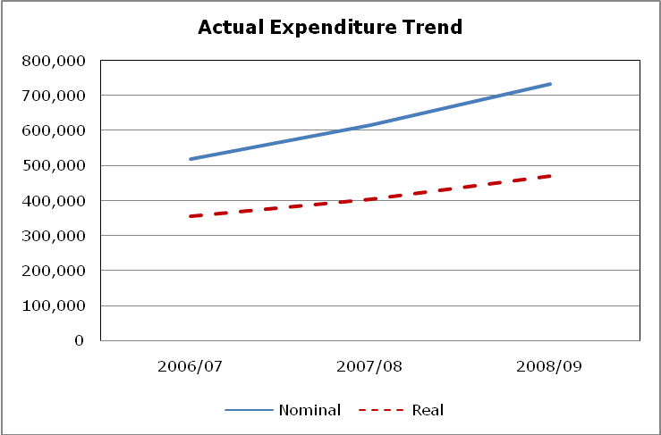
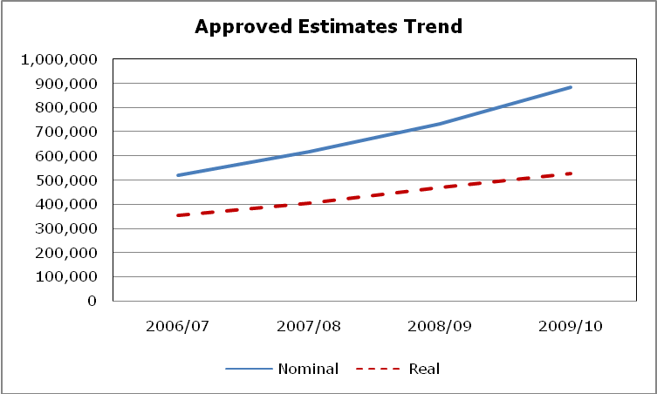
Chapter 7: Human Resource Status in the Health Sector

The health sector is facing the crisis of staff shortage. Acute lack of medical personnel is a national issue. As a result this is threatening the operations to serve millions of patients/clients in the country.
In order to avert the threat posed by the crisis, concerted efforts by the Government and various stakeholders in the health sector are geared towards producing additional human resources.

Referring back in year 2006 the statistics shows that a total of 82,277 health workers of various cadres were required. The actual numbers of various cadres for health in 2006 were 29,063 implying that there was a deficit of about 53,214 (65%) health workers.

The total number of health workers was 52,637 as was at December 2010 which is 64% of the actual requirement. The deficit was 29,650 (36%) of the actual requirement.

The trend of health workers is as shown below:-

YEAR |  | NUMBER AVAILABLE | DEFICIT
Jan – June, 2005 |  | 29,063 | 53,214
2005/2006 |  | 33,715 | 48,562
2006/2007 |  | 38,527 | 43,750
2007/2008 |  | 41,537 | 40,740
2008/2009 | 44,547 |  | 37,730
2009/2010 | 48637 |  | 33,640
Dec 2010 | 54,637 |  | 27,640

However, for a long time the MOHSW has been facing a problem of a reliable system for capturing the detailed human resource for health information of all cadres. But efforts have been made by introducing a computerized system to capture human resource for health information comprehensively. Currently the system has already been functional to eight regions. Therefore in the next publications the MOHSW will rely on this system to report detailed human resource information.

Chapter 8: Conclusion, issues and challenges
The report provides comprehensive assessment of the performance of the health sector for the 2008/09 financial year. In line with HSSP III indicators, data presented in this report have been updated or added for the 43 health sector performance indicators. To date, a few of the indicators have not been updated due to limitations of the routine data systems. In addition to the limitations presented by system delays, other data sources such as surveys and population census, are either ongoing or not yet due. This reports general summary focuses on the successful advancements achieved, to date, in the health sector. Important highlights include:

Areas of good performance

Health Status
- As indicated in the previous report, Tanzania is highly commended for the continuous and remarkable gains in Child Survival with experiencing a significant decline in Under Five Mortality Rate and Infant Mortality Rate. This places Tanzania on target for the MKUKUTA and MDG indicators. However, neonatal deaths have experienced smaller gains comprising 32% of all under five deaths in Tanzania. This continues to provide a challenge in improving the entire process of reducing Child Mortality.

- Due to the substantial decline in child mortality, life expectancy projections for 2010 are 57 for males and 59 for females. This will be confirmed by 2012 population census results.

Service Delivery Development
- The Tanzania Mainland OPD attendance per capita is 0.74; an increase from 0.68 from the previous year. This indicator also shows an improvement in the utilization of health facilities by populations.

- Measles vaccination remains high (91%); an increased from 88% in 2008. Moreover, this figure is above the HSSPIII 2015 goal of 85% of the population receiving measles vaccinations.

- Performance of DPT-HB3 for 2009 is 85.7% which is slightly below the last year performance of 86%. However, this figure is slightly above HSPSIII 2015 target of 85%.

- ANC attendance among pregnant women before 16 weeks of gestation has improved from 14% in 2008 to 47% in 2009. However, reaching the 2010 RCH target of 60% remains a challenge.

- On average 54% of deliveries were attended in health facilities. This figure implies that health facility deliveries have experienced an increase from 51% and 52% in 2007 and 2008, respectively. However, achieving the 2015 HSPSIII target of 80% remains a challenge.

- Tanzania’s TB treatment success rate is one of the highest in the world at 88%; and sits above the international standard set by the 2015 HSPSIII target.

- Various studies indicate a major reduction of the incidence of Malaria. At this time, there is no updated information for 2009.
Roughly 43% of HIV positive women in 2009 received ARVs to prevent MTCT. This is an increase from 34% in 2007 (RCH, 2009). This increase is significant and if maintained, Tanzania will achieve the 2015 HSPSIII target of 80%.

- By the end of May 2010, a total of 342,981 people were receiving ART which is an increase from 248,280 in 2009. Despite this significant increase, this remains below the 2010 NACP target of 440,000. Currently, Tanzania’s numbers are is equivalent to 80% of the target; which signifies a high likelihood of successfully attaining the 2010 NACP target.

Annexes

Annex 1: HSSP III Indicators up to 2009

S/N | Indicator | Numerator | Denominator | Baseline 2008 | 2009 status | Target by 2015 | Data Source | Type | Frequency
Health Status
1 | Neonatal mortality rate (per 1,000 live births) | Number of children who die within a first month of life | Number of live births in a year | 32 per 1000 live births (2007/08 (THIMS) | 26 per 1000 live births (TDHS 2009/10) | 19 per 1000 live births | TDHS, THMIS Population census | Impact | TDHS and THMIS intervals
2 | Infant mortality rate (per 1,000 live births) | Number of children who die before reaching one year of age | Number of live births in a year | 58 per 1000 live births (2007/08 THMIS) | 51 per 1000 live births (TDHS 2009/10) | 50 per 1,000 live birth | TDHS, THMIS , Population Census | Impact | TDHS interval
3 | Under-five mortality rate (per 1,000 live births) | Number of children who die before reaching five years of age | Number of live births within five years | 91 per 1000 live births (TDHS 2004/05) | 81 per 1000 live births (TDHS 2009/10) | 79 per 1000 live births in 2010 & 48 per 1000 in 2015 | TDHS, THMIS, Population census | Impact | TDHS interval
4 | Proportion of under-fives severely underweight (weight for age) | Number of children under five years who were severely underweight | Number of children born in five years preceding the survey | 3.7% | 3.8% | 2.0% | TDHS | Impact | TDHS interval
5 | Proportion of under-fives severely stunted (height for age) | Number of children under five years who were severely stunted | Number of children born in five years preceding the survey | 38% | 16.5% | 20% | TDHS | Impact | TDHS interval
6 | Maternal mortality ratio (per 100,000 live births) | Number of maternal deaths | Number of 100,000 live births in a year | 578 Maternal death per 100,000 | To be obtained from NBS | 265 Maternal death per 100,000 | TDHS | Impact | TDHS interval
7 | Life expectancy at birth | Life Expectancy module | Life Expectancy module | Female 52  Male 51  (Census 2005) | Female 52  Male 51  (Census 2005) | Female 62,  Male 59,  by 2025.⁴ | Census | Impact | Census Interval
8 | Proportional of pregnant women who are under 20 years | Number of women under 20 who became pregnant in a year specified by the survey | Total number of women under 20 years as specified by the survey | 54% (TDHS 2004/05) | 39.2%¹ | 39.2%¹ | TDHS | Process | Annual/ TDHS interval
9 | Total fertility rate of women 15-49 years | Total of fertility at a given point in time | Total number of women in the reproductive age group 15 – 49 years | 5.7% | 5.4% | Trend | TDHS | Impact | TDHS interval
10 | HIV prevalence among pregnant women aged 15-24 | Number of pregnant women aged 15 – 24 years who were tested to be HIV positive | Total number of pregnant women in the age group 15 – 24 years during the survey period | 6.7% | 6.7% | 5% | THIMS | Impact | TDHS interval
11 | HIV Prevalence Among 15-24 year old population male/female | Number of people aged 15 – 24 years who were tested to be HIV positive | Total population in the age group 15 – 24 years during the survey period | 6.1% (2004) | 6.1% (2004) | 5% | TDHS | Impact | TDHS interval
12 | HIV prevalence among 15 - 49 years old population male/female | Number of people aged 15 – 49 years who were tested to be HIV positive | Total population in the age group 15 – 49 years who were tested during the survey period | Female 6.8%  Male 4.7%  All Sex 5.8%  (THMIS 2007/08) | Female 6.8%  Male 4.7%  All Sex 5.8%  (THMIS 2007/08) | Female 6.8%  Male 4.7%  All 5.8%  (THMIS 2007/08) | THMIS | Impact | THMIS  interval
13 | Proportion of children orphaned by AIDS | Number of orphans due to AIDS | Total number of orphans | 10% (2005) | 10% (2005) | Trend | TDHS | Impact | TDHS interval
Service Delivery
General
14 | Outpatient attendance per capita | Total number of OPD attendance in a year | Total population in a year | 0.68 | 0.74 | 0.80 | HMIS | Output | Annual
Vaccinations¹³
15 | V1 Proportion of children under one vaccinated against measles | Total number of children under one year vaccinated against measles | Total number of children under one year in a year | 92% | 84.4% | 85% | HMIS | Outcome | Annual  TDHS interval
16 | V2 Proportion of children under one vaccinated 3 times against DPT –Hb3 | Total number of children under one year vaccinated 3 times against DPT - Hb | Total number of children under one year in a year | 91% (HMIS 2007) | 61.3% | 90% in 90% of the districts² | HMIS | Outcome | Annual  TDHS interval
17 | V3 Proportion of children under 5 receiving vitamin A twice per year | Number of children under 5 years who received vitamin A twice | Total number of children under 5 years in a year | 95% | 60.3% | 80%² | HMIS  TDHS | Outcome | Annual  TDHS interval
18 | V4 Proportion of women receiving at least 2nd doses of TT vaccination | Number of pregnant women who has received at least 2 doses of TT vaccination during pregnancy | Total number of pregnant women | 85 % | 73.1% | 85 % | HMIS  TDHS | Outcome | Annual  TDHS interval
Reproductive Health
19 | Proportion of pregnant women start ANC before 16 weeks of gestation age | Number of pregnant women who start ANC before 16 weeks of gestation age | Total number pregnant women | 14% | 47% | Trend | HMIS | Process | Annual TDHS interval
20 | Proportion of pregnant women attending ANC at least 4 times during pregnancy | Number of pregnant women attending ANC at least 4 times during pregnancy | Total number of pregnant women | 64% (2004/05) | 64% (2004/05) | 80% | HMIS  TDHS | Outcome | Annual  TDHS interval
21 | Proportion of births attended by trained personnel in health facility | Number of deliveries conducted in health facilities | Projected number of births | 51% | 54% (HMIS)  (50.6% Delivered by Health Professional,  50.2% delivered in a health facility) TDHS 2008/09 | 80% | HMIS | Outcome | Annual  TDHS interval
22 | Contraceptive prevalence rate | Number of contraceptive active users | Number of women of child bearing age | 20% (2004/05) | 28% | 30% | HMIS | Outcome | Annual  TDHS interval
23 | Percentage of (1) health Centers and (2) Dispensaries that can provide EmOC as defined in EHP | Number of (1) health Centers and (2) Dispensaries that can provide EmOC as defined in EHP | Total number of (1) health Centers and (2) Dispensaries providing reproductive and child health services | 5% (2004/05)  Total average of (1)+(2) | 5% (2004/05)  Total average of (1)+(2) | 40% (1)  40% (2) | Survey | Input | Survey
24 | Maternal Case Fatality Rate in health facilities | Number deaths due to maternal complications | Number of women admitted due to maternal complications |  | 1909 deaths |  | HMIS | Output | Annual
HIV/AIDS
25 | Percentage of HIV positive women receiving ARVs to prevent MTCT | Number of HIV positive women receiving ARVs for PMTCT | Number of HIV positive women | 34% (2007) | 50.9% | 80% | NACP | Output | Annual
26 | Number of persons with advanced HIV infection receiving ARV combination treatment (disaggregated under 15 and 15 and above and sex) | Number of persons with advanced HIV infection receiving ARV combination treatment (disaggregated under 15 and 15and above and sex) | Projected number of persons with advanced HIV infection | (By end of 2007)  11,176 (<15)  124,470 (15+) | (By end of 2007)  11,176 (<15)  124,470 (15+) | t.b.d | NACP | Output | Annual
Malaria
27 | Proportion of mothers who received two doses of preventive intermittent treatment for malaria during last pregnancy | Number of mothers receiving 2 doses of SP during pregnant within past 2 years | Number of mothers surveyed who delivered live births in past 2 years | 57%  (2008) | 57%  (2008) | 80% | MIS and other household surveys | Output | Annual
28 | Proportion of vulnerable groups (pregnant women 15-49 yrs of age, children under 5) sleeping under an ITN the previous night | Number of children <5 or pregnant women 15-49 yrs sleeping under ITN night before survey | Number of children <5 or pregnant women 15-49 yrs who reside in surveyed households | <5 yrs: 26%  PW: 27%  (2008) | <5 yrs: 26%  PW: 27%  (2008) | 60% | MIS and other household surveys | Outcome | Annual
29 | Proportion of laboratory confirmed malaria cases among all OPD visits (disaggregated under 5 and 5 and above) | Number of positive by microscopy or RDT | Number of OPD visits | Pending 2008 data under analysis | To be obtained from IHI | Pending | HMIS/Sentinel surveillance | Outcome | Annual
30 | Prevalence of Malaria parasitaemia (under 5 years) | Number of children positive by microscopy | # children tested by microscopy | 18%  (2008) | To be obtained from IHI | 5% | MIS and other household surveys | Impact | Biannual
Tuberculosis and Leprosy
31 | TB Notification rate per 100,000 population | Number of tuberculosis cases diagnosed | Total population | 163/100,000 | 61% |  | NTLCP | Output | Annual
32 | Percent of TB Cases Treatment success | Number of tuberculosis cases diagnosed | Number of patients who successfully completed treatment | 84.7% (2006) | 88.3% | 82% | NTLCP | Output | Annual
33 | Proportion of Leprosy cases diagnosed and successfully completed treatment | Number of Leprosy cases diagnosed and successfully treated | Number of notified leprosy cases | PB 97%  MB 91.7% | PB 97.9%  MB 93% | t.b.d | NTLCP | output | Annual
Infectious and non-communicable diseases
34 | Incidence of cholera | Number of cholera cases in a year | Total population at risk | 3,284 (2005) | 10,161 | t.b.d | HMIS | Outcome | Annual
35 | Proportion of treated cases of cholera who died | Total number of treated cases of cholera who died | Total number of treated cholera cases |  | 1.4% | t.b.d | HMIS | Output | Annual
36 | Proportion of adult with high blood pressure | Number of adults (24-65 years) with BP>140/90 | Adults (24-65) population in survey area | 37% (2007) | To be obtained from NIMR | Reduced by 25% | Special survey | Impact | End survey
Health Systems
Financial
37 | Proportion of the National budget spend on health | National budget spend on health per given year | Total National budget spend per given year | 10.2% (PER 2007/08) | 10.14% | 15% | PER
38 | Total GoT and donor (budget and off-budget) allocation to health per capita | Total GoT and donor (budget and off-budget) allocation to health | Total population | Tsh. 13,193 | Tsh. 22,967 | Tsh. 52,800 (MKUKUTA) | PER 2007/08 | Input | Annual
39 | Proportion of population enrolled in CHF | Number enrolled on CHF | Total population | 9% | Data Not Available | 30% | PER | Process | Annual
Human Resources
40 | Medical Officers and Assistant Medical Officers per 10,000 population (by region) | Number of MOs and AMOs available | Total population | 0.4 MO’s per 10,000  0.7 MO’s and AMO’s per 10,000 | 0.24 MO’s per 10,000 Popn  0.42 AMO’s per 10,000 Popn | t.b.d | HMIS | Input | Annual
41 | Nurse-Midwives per 10,000 population (by region) | Number of Nurse-Midwives available | Total population | 2.6 per10,000 | 1.46 NM’s per 10,000 Popn | t.b.d | HMIS | Input | Annual
42 | Pharmacists and pharmacy-technicians per 10,000 population (by region) | Number of Pharmacists and Pharmacy technicians available | Total population | 0.15 per 10,000 | 0.04 Pharmacists per 10,000 Popn  0.06 Pharmacy Technicians per 10,000 Popn | t.b.d | HMIS | Input | Annual
43 | Health Officers per 10,000 population (by region) | Number of Health Officers available | Total population | 0.23 per 10,000  (2005) | 0.35 HO’s per 10,000 Popn | t.b.d | HMIS | Input | Annual
44 | Laboratory staff per 10,000 population (by region) | Number of Laboratory staff available | Total population | 0.27 per 10,000  (2005) | 0.16 Lab. Staff per 10,000 Popn | t.b.d | HMIS | Input | Annual
45 | Number of training institutions with full NACTE accreditation | Number of training institutions with full NACTE accreditation | Total number of training institutions | 1 | 15 | 116 | Baseline and  End Survey | Process | Twice in HSSP III
Logistics
46 | Percentage of public health facilities without any stock outs of 5 tracer drugs and 1 vaccine and medical devices and supplies (representing laboratory, theatre, ward and clinic) | Number of public health facilities without any stock outs of 5 tracer drugs and 1 vaccine and supplies (representing laboratory, theatre, ward and clinic) | Total number of public health facilities |  | To be followed up | t.b.d | Survey | Input | Annual

Annex II: Performance of Health Status Indicators

NO. | INDICATOR | Other Sources | TDHS (2004/05) | THMIS (2007/08) | TDHS  (2009/10) | TARGET by 2015
1. | Neonatal mortality rate (per 1,000 live births) | - | 32 | 29 | 26 | 19
2. | Infant mortality rate (per 1,000 live births) | - | 68 | 58 | 51 | -
3. | Under-five morality rate (per 1,000 live births) | - | 112 | 91 | 81 | 54
4. | Proportion of under-fives who are underweight | - | 22% | - | 3.8% | 14%
5. | Proportion of under-fives who are stunted | - | 38% |  | 16.5% | 22%
6. | Maternal mortality ratio (per 100,000 live births | - | 578 |  |  | 199
7. | Life expectancy at birth | 52 (F)  51 (M)  (Census2001/  2002) | - | - |  | 62 (F)  59(M)  (by 2025)
8. | Proportion of pregnant women who are under 20 yrs |  | 54% | - |  | -
9. | Total fertility rate of women 15-49 years |  | 5.7 | - |  | 5.2
10. | HIV Prevalence among 15-24 year old pregnant women tested | 6.8%  (NACP 05/06) | - | - |  | -
11. | HIV Prevalence among 15-24 year old population male/female |  |  | 3.6% (F)  1.1% (M) |  | -
12. | HIV prevalence among 15 - 49 years old population male/female |  |  | 6.8% (F)  4.7% (M) |  | -

Annex III: OPD Attendance per capital by region in 2009

Region | Total Attendance | Population Projection | OPD Attendance Per Capital
ARUSHA | 1,800,376 | 1,677,828 | 1.07
DAR ES SALAAM | 3,640,994 | 3,036,139 | 1.20
DODOMA | 1,080,179 | 2,077,069 | 0.52
IRINGA | 1,164,725 | 1,737,382 | 0.67
KAGERA | 543,981 | 2357782 | 0.23
KIGOMA | 1,341,326 | 1637938 | 0.82
KILIMANJARO | 1,341,800 | 1851741 | 0.72
LINDI | 584,298 | 905480 | 0.65
MANYARA | 624,730 | 1,349,569 | 0.46
MARA | 2,559,847 | 1,762,592 | 1.45
MBEYA | 1,123,149 | 2,570,756 | 0.44
MOROGORO | 1,381,521 | 2,096,952 | 0.66
MTWARA | 735,139 | 1,298,295 | 0.57
MWANZA | 2,702,508 | 3,464,566 | 0.78
PWANI | 1,436,772 | 1062137 | 1.35
RUKWA | 704,519 | 1,503,183 | 0.47
RUVUMA | 1,030,921 | 1,338,962 | 0.77
SHINYANGA | 2,369,093 | 3,692,946 | 0.64
SINGIDA | 1,054,764 | 1,330,931 | 0.79
TABORA | 1,552,696 | 2,274,627 | 0.68
TANGA | 1,530,423 | 1,923,468 | 0.80
Total | 30,303,761 | 40,950,343 | 0.74

Annex IV: Proportional of Children Under One Vaccinated Against Measles 2009

Region | Measles
Region | Target | Vaccinated | %
ARUSHA | 59,769 | 55,327 | 93
DAR ES SALAAM | 98,905 | 96,362 | 97
DODOMA | 66,679 | 74,979 | 112
IRINGA | 57,244 | 47,161 | 82
KAGERA | 111,610 | 95,863 | 86
KILIMANJARO | 46,105 | 41,212 | 89
LINDI | 31,117 | 24,294 | 78
MANYARA | 55,232 | 38,932 | 70
MARA | 76,935 | 68,607 | 89
MBEYA | 111,332 | 98,271 | 88
MOROGORO | 70,366 | 65,960 | 94
MTWARA | 44,537 | 39,287 | 88
MWANZA | 131,730 | 146,876 | 111
PWANI | 36,519 | 31,756 | 87
RUKWA | 56,630 | 30,091 | 53
RUVUMA | 49,729 | 43533 | 88
SHINYANGA | 175,092 | 150,910 | 86
SINGIDA | 47,144 | 47,104 | 100
TABORA | 107,026 | 87,946 | 82
TANGA | 64,938 | 65,085 | 100
KIGOMA | 65,051 | 66,672 | 102
NATIONAL | 1,563,690 | 1,416,228 | 91

Annex V: Vaccine againist Diphtheria, Pertussis, Tetanus

and Hep B DPT_HB3 Coverage by age 12 Months in 2009.

No. | Region |  | DTPHepB3
No. | Region | Target | Vaccinated | %
1 | ARUSHA | 59,769 | 54,369 | 91.0
2 | DAR ES SALAAM | 98,905 | 102,230 | 103.4
3 | DODOMA | 66,679 | 73,513 | 110.2
4 | IRINGA | 57,244 | 46,126 | 80.6
5 | KAGERA | 111,610 | 95,416 | 85.5
6 | KILIMANJARO | 46,105 | 39,072 | 84.7
7 | LINDI | 31,117 | 22,042 | 70.8
8 | MANYARA | 55,232 | 45,850 | 83.0
9 | MARA | 76,935 | 66,240 | 86.1
10 | MBEYA | 111,332 | 84,817 | 76.2
11 | MOROGORO | 70,366 | 66,539 | 94.6
12 | MTWARA | 44,537 | 36,752 | 82.5
13 | MWANZA | 131,730 | 119,523 | 90.7
14 | PWANI | 36,519 | 31,410 | 86.0
15 | RUKWA | 56,630 | 37,193 | 65.7
16 | RUVUMA | 49,729 | 42,057 | 84.6
17 | SHINYANGA | 175,092 | 149,166 | 85.2
18 | SINGIDA | 47,144 | 44,923 | 95.3
19 | TABORA | 107,026 | 78,703 | 73.5
20 | TANGA | 64,938 | 60,134 | 92.6
21 | KIGOMA | 65,051 | 43,922 | 67.5
 | Total | 1,563,690 | 1,339,997 | 85.7

Annex VI: Proportion of women receiving at least 2nd dose of TT vaccination
NO. | REGION | Projected Clients | TT Vaccination Coverage | %
1 | MOROGORO | 174933 | 166745 | 95.3
2 | TANGA | 70689 | 65812 | 93.1
3 | DODOMA | 79040 | 69312 | 87.7
4 | PWANI | 34225 | 29517 | 86.2
5 | DSM | 118595 | 99822 | 84.2
6 | ARUSHA | 64023 | 53086 | 82.9
7 | LINDI | 31117 | 25302 | 81.3
8 | SHINYANGA | 174318 | 137346 | 78.8
9 | KILIMANJARO | 46032 | 36065 | 78.3
10 | MARA | 77369 | 59404 | 76.8
11 | KAGERA | 111658 | 85261 | 76.4
12 | RUVUMA | 52615 | 37355 | 71.0
13 | RUKWA | 68483 | 48385 | 70.7
14 | TABORA | 104542 | 73434 | 70.2
15 | MBEYA | 111332 | 77622 | 69.7
16 | IRINGA | 54964 | 37374 | 68.0
17 | SINGIDA | 50324 | 34126 | 67.8
18 | MANYARA | 55174 | 35345 | 64.1
19 | MTWARA | 14585 | 8184 | 56.1
20 | MWANZA | 225142 | 108888 | 48.4
21 | KIGOMA | 78399 | 25231 | 32.2
 | TOTAL | 1797559 | 1313616 | 73.1

Annex VII : Proportion of pregnant women start ANC

before 16 weeks of gestation age 2009

NO. | REGION | Projections | <16 weeks | %
1 | ARUSHA | 64,006 | 16,363 | 26
2 | DAR ES SALAAM | 79,007 | 47,877 | 61
3 | DODOMA | 98,705 | 69,905 | 71
4 | IRINGA | 56,220 | 36,251 | 64
5 | KAGERA | 108,888 | 44,844 | 41
6 | KIGOMA | 78,399 | 31,812 | 41
7 | KILIMANJARO | 48,132 | 14,474 | 30
8 | LINDI | 31,042 | 15,895 | 51
9 | MANYARA | 55,261 | 19,818 | 36
10 | MARA | 77,369 | 43,838 | 57
11 | MBEYA | 111,332 | 50,980 | 46
12 | MOROGORO | 78,455 | 70,366 | 90
13 | MTWARA | 45,303 | 17,934 | 40
14 | MWANZA | 131,275 | 65,666 | 50
15 | PWANI | 36,117 | 10,972 | 30
16 | RUKWA | 68,483 | 34,182 | 50
17 | RUVUMA | 53,312 | 21,466 | 40
18 | SHINYANGA | 174,318 | 57,161 | 33
19 | SINGIDA | 50,324 | 28,985 | 58
20 | TABORA | 104,542 | 34,271 | 33
21 | TANGA | 76,944 | 26,145 | 34
 | TOTAL | 1,550,490 | 733,060 | 47

Annex VIII : Deliveries in Health Facilities 2009

NO. | REGION | Live Births | Health Facility Deliveries | % Delivery in HF
1 | ARUSHA | 57,519 | 31,535 | 54.8
2 | DAR ES SALAAM | 105,162 | 83,810 | 79.7
3 | DODOMA | 88,521 | 52,163 | 58.9
4 | IRINGA | 57,190 | 43,577 | 76.2
5 | KILIMANJARO | 43,271 | 31,227 | 72.2
6 | LINDI | 29,522 | 18043 | 61.1
7 | MANYARA | 59,907 | 22,076 | 36.9
8 | MARA | 91,058 | 39,791 | 43.7
9 | MBEYA | 124,543 | 49,673 | 39.9
10 | MOROGORO | 75,432 | 49,645 | 65.8
11 | MTWARA | 50,126 | 25,373 | 50.6
12 | MWANZA | 142,765 | 92,026 | 64.5
13 | PWANI | 40,075 | 26,638 | 66.5
14 | RUKWA | 75,126 | 36,994 | 49.2
15 | RUVUMA | 53,313 | 36,566 | 68.6
16 | SHINYANGA | 190,942 | 69,416 | 36.4
17 | SINGIDA | 50,325 | 30,842 | 61.3
18 | TANGA | 65,939 | 38,397 | 58.2
19 | KAGERA | 129,816 | 87,942 | 67.7
20 | KIGOMA | 93,080 | 41,192 | 44.3
21 | TABORA | 114,782 | 32,639 | 28.4
 | TOTAL | 1,738,413 | 939,565 | 54.0

Annex IX: Maternal Deaths by Region and Causes

 | Septice Septicaemiamia | Others | Ruptured Uterus | Relapsing Fever | Pulmonary Oedema | Puerperial Sepsis | PPH | Pneumonia | Obstructed Labour | Meningitis | Malaria | HIV/AIDS | EPH Gestosis | Eclampsia | APH | Anaemia | Cardio mayopathy | Total
Kigoma | 2 | 8 | 2 | 0 | 0 | 10 | 24 | 0 | 3 | 0 | 0 | 2 | 3 | 6 | 5 | 8 | 0 | 73
Shinyanga | 1 | 28 | 2 | 1 | 0 | 30 | 26 | 0 | 7 | 1 | 8 | 11 | 0 | 14 | 3 | 21 | 0 | 153
Tabora | 23 | 9 | 4 | 0 | 0 | 11 | 30 | 0 | 4 | 1 | 12 | 12 | 3 | 27 | 9 | 19 | 0 | 164
Arusha | 0 | 0 | 0 | 0 | 3 | 0 | 10 | 0 | 0 | 0 | 0 | 4 | 0 | 6 | 0 | 9 | 0 | 32
Kilimanjaro | 4 | 11 | 0 | 2 | 0 | 2 | 5 | 0 | 0 | 0 | 2 | 6 | 2 | 5 | 1 | 2 | 0 | 42
Tanga | 6 | 0 | 7 | 0 | 0 | 0 | 13 | 0 | 2 | 0 | 0 | 0 | 0 | 10 | 10 | 0 | 0 | 48
Mbeya | 9 | 24 | 4 | 0 | 0 | 7 | 10 | 0 | 0 | 0 | 10 | 27 | 1 | 8 | 2 | 8 | 0 | 110
Rukwa | 8 | 8 | 2 | 0 | 2 | 3 | 14 | 0 | 7 | 0 | 5 | 1 | 0 | 7 | 1 | 5 | 0 | 63
Iringa | 12 | 0 | 0 | 0 | 0 | 0 | 19 | 0 | 9 | 0 | 6 | 4 | 1 | 13 | 1 | 6 | 0 | 71
Dodoma | 5 | 0 | 0 | 0 | 0 | 11 | 31 | 1 | 2 | 1 | 21 | 11 | 0 | 7 | 1 | 7 | 0 | 98
Manyara | 0 | 7 | 0 | 0 | 0 | 5 | 20 | 0 | 0 | 0 | 5 | 1 | 0 | 0 | 1 | 6 | 0 | 45
Singida | 5 | 8 | 1 | 0 | 1 | 4 | 9 | 0 | 2 | 0 | 3 | 2 | 0 | 5 | 5 | 4 | 0 | 49
Morogoro | 20 | 0 | 4 | 0 | 0 | 4 | 13 | 0 | 2 | 0 | 4 | 11 | 2 | 33 | 5 | 5 | 0 | 103
DSM | 0 | 0 | 11 | 0 | 2 | 2 | 34 | 1 | 2 | 0 | 2 | 15 | 2 | 20 | 1 | 12 | 33 | 137
Pwani | 0 | 0 | 0 | 0 | 0 | 2 | 9 | 0 | 1 | 0 | 0 | 1 | 0 | 9 | 1 | 7 | 0 | 30
Mtwara | 0 | 10 | 5 | 0 | 0 | 8 | 17 | 3 | 1 | 0 | 0 | 0 | 3 | 4 | 2 | 5 | 0 | 58
Ruvuma | 0 | 4 | 5 | 11 | 6 | 0 | 0 | 0 | 0 | 8 | 1 | 1 | 2 | 0 | 1 | 5 | 0 | 44
Lindi | 0 | 0 | 6 | 0 | 0 | 4 | 7 | 0 | 2 | 0 | 2 | 2 | 3 | 4 | 4 | 5 | 0 | 39
Mwanza | 9 | 15 | 8 | 0 | 0 | 14 | 35 | 0 | 13 | 1 | 9 | 20 | 0 | 27 | 9 | 16 | 0 | 176
Mara | 0 | 15 | 1 | 0 | 0 | 6 | 20 | 4 | 3 | 0 | 7 | 1 | 0 | 6 | 8 | 0 | 0 | 71
Kagera | 4 | 13 | 0 | 0 | 1 | 6 | 14 | 0 | 8 | 0 | 1 | 2 | 2 | 1 | 4 | 3 | 0 | 59
NATIONAL TOTAL | 108 | 160 | 62 | 14 | 15 | 129 | 360 | 9 | 68 | 12 | 98 | 134 | 24 | 212 | 74 | 153 | 33 | 1665
Annex X : Percentage of HIV positive women receiving ARVs to prevent MTCT 2009

NO. | REGION | Number Detected HIV+ | Number Received ARV | %
1 | ARUSHA | 1,519 | 577 | 38.0
2 | DAR ES SALAAM | 6,503 | 1,269 | 19.5
3 | DODOMA | 1,378 | 1,101 | 79.9
4 | IRINGA | 5,194 | 3,188 | 61.4
5 | KAGERA | 2,266 | 1,084 | 47.8
6 | KIGOMA | 800 | 456 | 57.0
7 | KILIMANJARO | 1,138 | 279 | 24.5
8 | LINDI | 24,188 | 533 | 2.2
9 | MANYARA | 465 | 274 | 58.9
10 | MARA | 1,478 | 692 | 46.8
11 | MBEYA | 5,992 | 4,722 | 78.8
12 | MOROGORO | 1,870 | 893 | 47.8
13 | MTWARA | 1,166 | 731 | 62.7
14 | MWANZA | 4,457 | 2,363 | 53.0
15 | PWANI | 3,007 | 987 | 32.8
16 | RUKWA | 1,639 | 835 | 50.9
17 | RUVUMA | 1,600 | 867 | 54.2
18 | SHINYANGA | 4,910 | 2,780 | 56.6
19 | SINGIDA | 874 | 428 | 49.0
20 | TABORA | 18,302 | 14,440 | 78.9
21 | TANGA | 2,056 | 759 | 36.9
 | NATIONAL TOTAL | 90,802 | 39,258 | 43.2

Source: HMIS/RCH 2009
Annex XI: Number of persons with HIV infection receiving ARV combination therapy

No. | Region | Number of Facilities Providing Care and Treatment | Total on Care | Total on ARV
1 | Dodoma | 28 | 16,123 | 9932
2 | Arusha | 48 | 25,818 | 14,311
3 | Kilimanjaro | 40 | 28,026 | 13,625
4 | Tanga | 30 | 28,576 | 15,296
5 | Morogoro | 31 | 27,961 | 15,536
6 | Coast | 18 | 20,841 | 9,957
7 | Dar es Salaam | 62 | 113,515 | 66,719
8 | Lindi | 51 | 9,620 | 4,440
9 | Mtwara | 44 | 16,989 | 8,165
10 | Ruvuma | 28 | 25,755 | 13,337
11 | Iringa | 44 | 71,926 | 37,196
12 | Mbeya | 47 | 82,323 | 42,105
13 | Singida | 19 | 8,133 | 5,134
14 | Tabora | 33 | 25,296 | 10,252
15 | Rukwa | 17 | 10,028 | 4,622
16 | Kigoma | 28 | 13,264 | 5,501
17 | Shinyanga | 44 | 36,501 | 18,216
18 | Kagera | 43 | 25,687 | 11,479
19 | Mwanza | 33 | 51,038 | 22,696
20 | Mara | 35 | 20,665 | 10,916
21 | Manyara | 20 | 7,412 | 3,546
 | National Total | 743 | 665,497 | 342,981

Annex XII: Percent of TB treatment success rate in 2009

REGION | Cured | Treatment Completed | Failure | Died | Out of Control | Transferred out | Total  Evaluated | Reported 2008 | Treatment Success rate
DAR ES SALAAM | 4,929 | 19 | 14 | 247 | 168 | 366 | 5,743 | 5,787 | 86
ARUSHA | 559 | 178 | 1 | 22 | 27 | 46 | 833 | 850 | 87
DODOMA | 629 | 24 | 1 | 34 | 10 | 13 | 711 | 711 | 92
IRINGA | 812 | 62 | 2 | 134 | 24 | 27 | 1,061 | 1,061 | 82
KAGERA | 931 | 15 | 1 | 24 | 16 | 7 | 994 | 994 | 95
KIGOMA | 288 | 38 | 2 | 22 | 14 | 9 | 373 | 373 | 87
KILIMANJARO | 637 | 41 | 1 | 46 | 26 | 54 | 805 | 805 | 84
LINDI | 475 | 24 | 0 | 35 | 21 | 19 | 574 | 581 | 86
MANAYARA | 647 | 91 | 1 | 51 | 25 | 15 | 830 | 830 | 89
MARA | 763 | 10 | 7 | 25 | 27 | 26 | 858 | 858 | 90
MBEYA | 973 | 56 | 4 | 96 | 9 | 17 | 1,155 | 1,155 | 89
MOROGORO | 1,118 | 93 | 1 | 46 | 5 | 40 | 1,303 | 1,303 | 93
MTWARA | 890 | 22 | 0 | 31 | 9 | 12 | 964 | 964 | 95
MWANZA | 1,853 | 182 | 2 | 139 | 86 | 77 | 2,339 | 2,339 | 87
PWANI | 901 | 1 | 2 | 52 | 14 | 9 | 979 | 979 | 92
RUKWA | 348 | 1 | 1 | 22 | 3 | 4 | 379 | 379 | 92
RUVUMA | 326 | 15 | 3 | 24 | 0 | 5 | 373 | 373 | 91
SHINYANGA | 1,199 | 63 | 1 | 91 | 59 | 47 | 1,460 | 1,460 | 86
SINGIDA | 374 | 12 | 1 | 25 | 0 | 18 | 430 | 440 | 88
TABORA | 326 | 76 | 1 | 19 | 20 | 23 | 465 | 458 | 88
TANGA | 1,044 | 69 | 3 | 50 | 13 | 27 | 1,206 | 1,206 | 92
NATIONAL | 20,022 | 1,092 | 49 | 1,235 | 576 | 861 | 23,835 | 23,906 | 88
Percent-outcome | 83.8 | 4.6 | 0.2 | 5.2 | 2.4 | 3.6 | 99.7 | 100.0

Annex XIII: Treatment outcome of PB leprosy cases notified in 2007

S/N | REGION | Treatment  Completed | Died | Transfer  out | Out of  Control | Total  Evaluated | Reported  2007 | Completion  rate | Case  holding
1 | Dar Ilala I | 21 | 0 | 0 | 2 | 23 | 23 | 91 | 100
2 | Dar Kinondoni | 24 | 0 | 0 | 0 | 24 | 24 | 100 | 100
3 | Dar Temeke | 18 | 0 | 0 | 1 | 19 | 19 | 95 | 100
4 | Dar Ilala II | 0 | 0 | 0 | 0 | 0 | 0 | 0 | 0
 | Dar es Salaam | 63 | 0 | 0 | 3 | 66 | 66 | 95 | 100
5 | Arusha | 1 | 0 | 0 | 0 | 1 | 1 | 100 | 100
6 | Dodoma | 8 | 0 | 0 | 0 | 8 | 8 | 100 | 100
7 | Iringa | 3 | 0 | 0 | 0 | 3 | 3 | 100 | 100
8 | Kagera | 47 | 0 | 0 | 1 | 48 | 48 | 98 | 100
9 | Kigoma | 61 | 0 | 0 | 2 | 63 | 63 | 97 | 100
10 | Kilimanjaro | 3 | 0 | 0 | 0 | 3 | 3 | 100 | 100
11 | Lindi | 52 | 0 | 0 | 0 | 52 | 52 | 100 | 100
12 | Manyara | 3 | 0 | 0 | 0 | 3 | 3 | 100 | 100
13 | Mara | 17 | 0 | 0 | 0 | 17 | 17 | 100 | 100
14 | Mbeya | 5 | 0 | 0 | 0 | 5 | 5 | 100 | 100
15 | Morogoro | 107 | 0 | 0 | 0 | 107 | 107 | 100 | 100
16 | Mtwara | 118 | 0 | 0 | 2 | 120 | 120 | 98 | 100
17 | Mwanza | 10 | 0 | 0 | 0 | 10 | 10 | 100 | 100
18 | Pwani | 102 | 0 | 1 | 2 | 105 | 105 | 97 | 100
19 | Rukwa | 85 | 0 | 0 | 1 | 86 | 86 | 99 | 100
20 | Ruvuma | 35 | 0 | 0 | 0 | 35 | 35 | 100 | 100
21 | Shinyanga | 5 | 0 | 0 | 0 | 5 | 7 | 71 | 71
22 | Singida | 3 | 0 | 0 | 0 | 3 | 3 | 100 | 100
23 | Tabora | 23 | 0 | 0 | 2 | 25 | 25 | 92 | 100
24 | Tanga | 30 | 0 | 0 | 0 | 30 | 30 | 100 | 100
 | Mainland | 781 | 0 | 1 | 13 | 795 | 797 | 98 | 100

Source TB & Leprosy Program
Annex XIV: Treatment outcome of MB leprosy cases notified in 2006

S/N | REGION | Treatment  Completed | Died | Transfer  Out | Out of  Control | Total  Evaluated | Reported  2006 | Completion  Rate | Case  Holding
1 | Dar Ilala I | 75 | 1 | 2 | 9 | 87 | 87 | 86 | 100
2 | Dar Kinondoni | 94 | 0 | 2 | 6 | 102 | 102 | 92 | 100
3 | Dar Temeke | 63 | 0 | 4 | 7 | 74 | 74 | 85 | 100
4 | Dar Ilala II | 14 | 0 | 1 | 0 | 15 | 15 | 93 | 100
 | Dar es Salaam | 246 | 1 | 9 | 22 | 278 | 278 | 88 | 100
5 | Arusha | 1 | 0 | 0 | 0 | 1 | 1 | 100 | 100
6 | Dodoma | 93 | 0 | 1 | 2 | 96 | 96 | 97 | 100
7 | Iringa | 10 | 0 | 0 | 0 | 10 | 10 | 100 | 100
8 | Kagera | 75 | 1 | 1 | 5 | 82 | 82 | 91 | 100
9 | Kigoma | 165 | 0 | 2 | 7 | 174 | 174 | 95 | 100
10 | Kilimanjaro | 9 | 0 | 1 | 1 | 11 | 11 | 82 | 100
11 | Lindi | 164 | 1 | 2 | 5 | 172 | 172 | 95 | 100
12 | Manyara | 5 | 0 | 0 | 0 | 5 | 5 | 100 | 100
13 | Mara | 17 | 1 | 1 | 2 | 21 | 21 | 81 | 100
14 | Mbeya | 66 | 5 | 2 | 3 | 76 | 78 | 85 | 97
15 | Morogoro | 323 | 3 | 0 | 7 | 333 | 337 | 96 | 99
16 | Mtwara | 262 | 2 | 0 | 2 | 266 | 266 | 98 | 100
17 | Mwanza | 155 | 0 | 3 | 15 | 173 | 173 | 90 | 100
18 | Pwani | 129 | 3 | 0 | 5 | 137 | 137 | 94 | 100
19 | Rukwa | 220 | 1 | 0 | 1 | 222 | 235 | 94 | 94
20 | Ruvuma | 68 | 0 | 0 | 0 | 68 | 67 | 101 | 101
21 | Shinyanga | 117 | 2 | 2 | 7 | 128 | 129 | 91 | 99
22 | Singida | 38 | 0 | 1 | 0 | 39 | 39 | 97 | 100
23 | Tabora | 151 | 2 | 0 | 22 | 175 | 175 | 86 | 100
24 | Tanga | 139 | 1 | 5 | 5 | 150 | 152 | 91 | 99
 | Mainland | 2,453 | 23 | 30 | 111 | 2,617 | 2,638 | 93 | 99

Annex XV: Number of Reported, Admission, and Death Cases of Cholera by Region in 2009

No | REGION | Reported Cases | Admitted | Death
1 | ARUSHA | 340 | 0 | 0
2 | DAR ES SALAAM | 596 | 590 | 19
3 | DODOMA | 2 | 0 | 0
4 | IRINGA | 0 | 0 | 0
5 | KAGERA | 0 | 0 | 0
6 | KIGOMA | 585 | 557 | 7
7 | KILIMANJARO | 495 | 242 | 3
8 | LINDI | 0 | 0 | 0
9 | MANYARA | 752 | 752 | 0
10 | MARA | 880 | 393 | 19
11 | MBEYA | 544 | 544 | 9
12 | MOROGORO | 0 | 0 | 0
13 | MTWARA | 0 | 0 | 0
14 | MWANZA | 287 | 271 | 32
15 | PWANI | 34 | 17 | 4
16 | RUKWA | 222 | 222 | 6
17 | RUVUMA | 0 | 0 | 0
18 | SHINYANGA | 4 | 4 | 0
19 | SINGIDA | 624 | 164 | 0
20 | TABORA | 0 | 0 | 0
21 | TANGA | 4798 | 4481 | 17
 | TOTAL | 10,163 | 8237 | 116

National Road Map Strategic Plan to Accelerate Reduction of Maternal, Newborn and Child Deaths in Tanzania 2008 – 2015.
Abuja Declaration 2005

